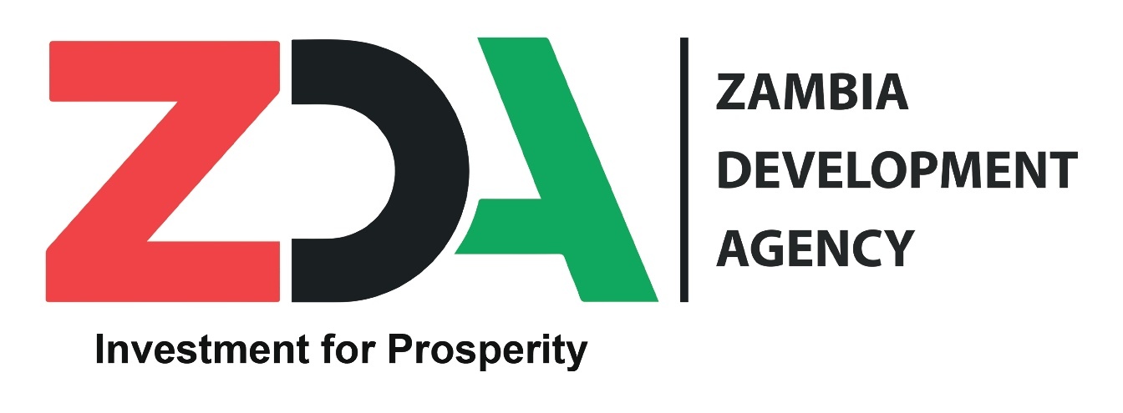

**2023 – Handbook for Zambian Exporters**

**Preface**

This handbook is crafted for convenient use by both new and existing exporters from Zambia. It is intended to provide guidance to entrepreneurs who are preparing to/or are exporting from Zambia. It is particularly targeted to be a reference book for those directly engaged in export related activities including export managers, personnel involved in export processes relating to documentation, shipping and bank officers as well as financiers and students.

# **ACRONYMS**

LIAZ Leather Industries Association of Zambia

LIBOR London Interbank Offered Rate

OPPAZ Organic Producers Association of Zambia

PTA Preferential Trade Area

SADC Southern African Development Community

SED Shippers Export Declaration

SSIAZ Small Scale Industries Association of Zambia

STR Simplified Trade Regime

UK United Kingdom

UNCTAD Nations Conference on Trade and Development

USA United States of America

WTO World Trade Organisation

ZACCI Zambia Chamber of Commerce and Industry

ZAM Zambia Association of Manufacturers

ZCSMBA Zambia Chamber of Small and Medium Business Associations

ZDA Zambia Development Agency

ZEDF Zambia Export Development Fund

ZEGA Zambia Export Growers Association

ZNFU Zambia National Farmers Union

# **1.0 PREPARING TO EXPORT**

# **1.1 Introduction**

Engaging in export business can be a challenging activity, complicated by factors such as distance, different social and economic conditions as well as different government regulations. Before a firm decides to enter an export market, a close and careful examination of the market opportunities available must be carried out.Export markets are very competitive and challenging. Exporting can be highly profitable and may strengthen an organisation’s business operations if executed well. The Zambia Development Agency’s (ZDA) objective is to help Zambian businesses explore foreign markets and establish sustainable export business.

# **1.2 When can goods be exported?**

Goods can only be exported or accepted for carriage for export after such entry or documentation has been delivered to the Customs by the exporter or agent, and duly processed. Exportation can be done by Road, Rail, Air, Pipeline and Maritime Transport.

# **1.3 What Can I export from Zambia?**

An exporter can export any product that does not appear on the negative list. Below is a list of some of the exportable products from Zambia:

Copper Wire Engineering ProductsCane Sugar Building MaterialsBurley Tobacco Gasoil/Petroleum OilsCotton Lint Electricity

Electrical Cables Maize & Maize SeedFresh Flowers Wheat & MeslinFresh Fruits & Vegetables Cement & LimeGemstones Nickel

Handcrafts and Curios Gold

Leather and Leather Products Chemicals and PharmaceuticalWood Products Product

# **1.4 Key Requirements for Successful Exporting**

Before any organization engages in export business, they need to be export ready and the products must be ready for the targeted market. The export process has three stages: feasibility analysis; planning foreign market entry; and implementation. The steps in these stages are outlined below:

# **1.4.1 Feasibility Analysis:**

1. Analyze domestic performance.
2. Assess the firm’s capacities.
3. Consider the demographics, social, political, and economic factors of target markets.
4. Confer with international trade experts (e.g. in the fields of marketing, finance, legal, and logistics).
5. Select target markets.
6. Identification of products with export potential

# **1.4.2 Planning Foreign Market Entry:**

1. Conduct market research into the industry sector.
2. Evaluate market research.
3. Decide how the product will be marketed.
4. Comply with target country licensing, standards and certification requirements.
5. Apply for the necessary patent, trademark, and copyright protection.
6. Identify taxes, tariffs, duties, quotas, or other non-tariff trade measures
7. Establish pricing schedule.
8. Seek financing.

# **1.4.3 Implementation**

1. Determine methods of distribution.
2. Implementation marketing plan.
3. Choose sales representatives, or sales methods.
4. Negotiate sales contract.
5. Produce finished product.
6. Obtain insurance cover
7. Complete the required paperwork.
8. Package and label the product.
9. Ship the product.

# **1.4.4 Most Common Mistakes Made by Exporters**

Success in the exporting business can be compromised by the following common mistakes:

1. Failure to seek qualified export counseling to develop an international strategy and marketing plan before starting up.
2. Insufficient commitment from top management to overcome the initial difficulties and financial requirements of exporting.
3. Inadequate care in selecting overseas sales representatives or distributors.Seeking orders from around the world rather than concentrating on one or two strategic geographical areas.
4. Neglecting export markets when the domestic market booms.Failure to treat international distributors and customers, on the same basis, as their domestic counterparts.
5. Assuming that a particular market technique and product will automatically be successful in all countries.
6. Failure to modify products in order to meet regulations or cultural preferences of foreign countries.
7. Failure to translate services, sales, and warranty documentation into the relevant language.
8. Failure to use an export management company if the firm cannot afford its own export department.
9. Failure to enter into licensing or joint venture agreements when the firm is reluctant to enter into foreign markets on its own, due to import restrictions, insufficient resources, or a limited product line.
10. Failure to provide an efficient after-sales service for the product.

# **1.4.5 Questions That Should Be Answered Before Making the Decision to Export**

Exporting involves a considerable investment of financial, managerial, and production resources. Therefore, an objective analysis is necessary before making the decision to export. It is important to consider the following questions:

# **1.4.6 Analysis of Domestic Performance**

1. Is my firm successful in the domestic market?
2. What is the current domestic market share of the product?

# **1.4.7 Firm's Commitment and Desire to Export**

1. What are the firm's exporting objectives?
2. Where is the exporting department in the firm's hierarchy?
3. Which members of the firm's personnel will be involved in the export process?
4. Is there a need to recruit additional personnel?
5. What international experience does the firm (or any of its employees) have?
6. How involved in the export process is the firm willing to be?
7. How much risk is the firm willing to take?

# **1.4.8 Competitive Analysis**

1. What makes the firm's products or services competitive in a foreign market?
2. What makes the products or services unique?
3. What are the overall competitive advantages (e.g. technological advancements, patents, skills)?

# **1.4.9 Finding Out About Target Foreign Markets**

1. What market segments are being targeted?
2. What level of stock needs to be maintained to sell abroad?
3. How are the firm's competitors performing in international markets?
4. Will the product be restricted due to tariffs, quotas, or other non-tariff barriers?
5. Does the product conflict with the culture, traditions, or beliefs of customers abroad?
6. Will patent/trademark protection abroad be essential for the product?
7. What product labelling requirements must be met?
8. What sort of environmental or other regulations need to be adhered to?
9. Have the traceability techniques of certain markets and products been considered?

# **1.4.10 Marketing the Product**

1. How will the product or service be advertised?
2. What companies, agents, or distributors have purchased similar products?
3. Who will represent the firm when selling abroad?
4. Will an agent or distributor be appointed to handle the export market?
5. What territory should the agent or distributor cover?
6. What non-competitive lines are acceptable for the agent or distributor to carry?
7. Can a potential buyer see a functioning model or sample of the product?
8. ooxWord://word/media/image11.jpegIs there a trade fair where the product or service can be presented?
9. Will the product or service be sold under the same name in the target foreign market?

# **1.4.11 Pricing and Commercial Terms**

1. How will the price be calculated?
2. What are the service terms?
3. What are the payment and credit terms?
4. What are the warranty and guarantee terms?
5. What are the discount terms?

# **2.0 EXPORT PROCEDURES AND DOCUMENTATION**

Zambia has one of the most liberalised and simplified export procedures. Rules and regulations pertaining to the export of non-traditional exports are nonrestrictive. Exports of grain are however sometimes subject to seasonal regulation to forecast shortages. In some cases, exporters are required to secure authority documents or other necessary certificates for export consignments of veterinary items, botanical items and submit them to customs.

An exporter wishing to export goods outside Zambia must register with the Zambia Revenue Authority for a Tax Payer Identification Number (TPIN). Those who wish to export under preference under regional agreements should also register with the Customs Division in the department of International and Policy.

# **2.1 General Procedures**

General procedure Comprise the following:

1. Complete the Customs and Excise Declaration Form CE 20 (Appendix I) from the Zambian Revenue Authority and indicate on it the range and value of products meant for export.
2. In order to benefit from preferential trade arrangement for duty free or quota free market access, apply for export registration of the product from the Zambia Revenue Authority (ZRA) in order for the Authority to issue a certificate of origin for markets you are about to export to. These markets include the Southern Africa Development Community (SADC), Common Market for East and Southern Africa (COMESA), European Union (EU), Africa Growth Opportunities Act (AGOA) and Generalized System of Preferences (GSP).
3. It is necessary to obtain import regulations from the importing market in order to meet the specific requirements for each product and country before embarking on exporting. Some countries may require conformity assessments and verification certification for each consignment from recommended institutions and laboratories.
4. ooxWord://word/media/image12.jpegAt the time of exporting the consignment, the exporter should submit the Customs and Excise Declaration form 20 accompanied by the following documents to customs officials at ports of exit:
5. Commercial Invoice
6. Packing List
7. Certificate of origin (duly signed by approved authorities where applicable)
8. Shipping consignment notes (airway bill/bill of lading)
9. It is advisable to insure each export consignment

# **2.2 Product Specific Procedures**

# **2.2.1 Animal and Fish Products**

* Obtain the veterinary certificate from the Veterinary Department before exporting live fish and live animals (including poultry);
* Obtain Health Permit for animal products and fish from the Ministry of Health ascertain safety for human health (microbiology, heavy metals, additives, veterinary drug residues, pesticide residues);
* Obtain the quality certificate from Veterinary Department before exporting meat and livestock out of Zambia (International Sanitary Certificate) in conformity with Animal Health regulations;
* Obtain a Permit to export Wild Animals, Meat or Trophies and a Convention for International Trade of Endangered Species (CITES) Certificate for animals listed in appendix I and II of the CITES. The Permit and the Certificate should be obtained from the Department of National Parks and Wild Life (DNPW);
* If you wish the exports to benefit from preferential trade arrangements under SADC or COMESA or Duty-Free Quota-Free Trade Arrangement in applicable countries:

1. Apply for export registration of the product from ZRA; and
2. Obtain a certificate of origin from ZRA.

* Obtain the importing country’s regulations to establish what is required in the import destination. The import requirement may vary from country to country.

# **2.2.2 Plant Products and Seed**

* Acquire a phytosanitary (SPS) certificate from Plant Quarantine and Phytosanitary Services (PQPS) for agriculture products such as Seeds, Stems and Fruits. For seeds attach seed test certificate from Seed Control and Certification Institute (SCCI);
* A Plant Import Permit (PIP) from the importing country has to be presented by the exporter to the Inspector as this carries recommendations (or conditions) that the exporting country has to follow;
* Obtain Health Permit for plant products from the Ministry of Health ascertain safety for human health (check for yeasts and moulds, aflatoxins, fumonsins, Deoxynivalenol, pesticide residues, heavy metals);
* Thereafter, the exporter proceeds to the Ministry of Agriculture to apply for an Export Permit; and
* If you wish the exports to benefit from preferential trade arrangements under SADC or COMESA or Duty-Free Quota-Free Trade Arrangement in applicable countries:

1. Apply for export registration of the product from ZRA; and
2. Obtain a certificate of origin from ZRA.

# **2.2.3 Cereal Products**

* Acquire a phytosanitary (SPS) certificate from Plant Quarantine and Phytosanitary Services (PQPS) for agriculture products such as Grain, Stems and Fruits, from Zambia Agriculture and Research Institute (ZARI);
* Obtain Health Permit for grain and cereal products from the Ministry of Health to ascertain safety for human health (check for yeasts and moulds, aflatoxins, fumonsins, Deoxynivalenol, pesticide residues, heavy metals);
* Obtain an Export Permit for regulated food products such as maize, maize meal, maize bran, wheat and wheat flour from Ministry of Agriculture, Agribusiness and Marketing Department (Import and Export Permit Office); and
* If you wish the exports to benefit from preferential trade arrangements under SADC or COMESA or Duty-Free Quota-Free Trade Arrangement in applicable countries:

1. Apply for export registration of the product from ZRA;
2. Obtain a certificate of origin from ZRA.

# **2.2.4 Precious and Semi-precious Stones**

* Acquire a mining license or mineral processing license or mineral trading permit from Ministry of Mines and Minerals Development;
* Apply online in the Mineral Output Statistical Evaluation System (MOSES);
* Samples of mineral product to be exported are to be provided for the purposes of laboratory analysis and valuation to Geological Survey Department, in order to obtain the Mineral Export Permit;
* Obtain Mineral Royalty Clearance Certificate from ZRA;
* Obtain security clearance from Zambia Police Service in the area where the material is mined;

* Obtain Mineral Export Permit for precious and semi-precious stones exports from the Ministry of Mines and Minerals Development (Mineral Export Permit);
* Exporters are expected to fill in form (v) of the Mines and Minerals Development (General) Regulations, 2016;
* Where applicable, exporters are encouraged to obtain import requirements from the importing country; and
* If you wish the exports to benefit from preferential trade arrangements under SADC or COMESA or Duty-Free Quota-Free Trade Arrangement in applicable countries:

1. Apply for export registration of the product from ZRA
2. Obtain a certificate of origin from ZRA.

# **2.2.5 Chemical and Chemical Products**

* Obtain permit from Zambia Environmental Management Agency (ZEMA) for agri-chemicals, for products such as ammonium nitrates, pesticides, etc;
* For products such as fertilizer obtain the test certificate from Zambia Agriculture Research Institute (ZARI);
* Acquire an export permit from Zambia Medicines Regulatory Authority for medicinal products and dangerous drugs;
* Where applicable, exporters are encouraged to obtain import requirements from the importing country (repeat); and
* If you wish the exports to benefit from preferential trade arrangements under SADC or COMESA or Duty-Free Quota-Free Trade Arrangement in applicable countries:

1. Apply for export registration of the product from ZRA
2. Obtain a certificate of origin from ZRA.

# **2.2.6 Wood and Wood Products**

* Obtain Clearance Certificate for exports of raw timber from the Forestry Department;
* Obtain Phytosanitary Certificate from PQPS. Exporters are expected to present requirements from the importing country in order to obtain the Certificate;
* Obtain a certification mark from the Zambia Bureau of Standards;
* Exporters are encouraged to obtain import requirements from the importing country, as most countries require fumigation of exported timber products; and
* If you wish the exports to benefit from preferential trade arrangements under SADC or COMESA or Duty-Free Quota-Free Trade Arrangement in applicable countries:

1. Apply for export registration of the product from ZRA
2. Obtain a certificate of origin from ZRA.

# **2.3 Other Important Export Procedures**

i. All exporters are required to open and maintain a foreign currency denominated account with a commercial bank for receipt of all export proceeds.

ii. Receipts for all export transactions in value of, or in excess of US$5,000 or equivalent currency shall be Electronic Fund Transfer (EFT)

# **2.4 Documents Required by the Buyer**

The buyer will need a copy of the Bill of Lading (B/L). The B/L itself is not the actual contract between the owner of the goods and the carrier, although it does provide evidence of the contract. It is a receipt for goods shipped on board a vessel (from marine B/Ls) and provides proof of the title to the goods which are the subject of the contract between the buyer and the seller. There are two types: a straight bill of lading which is non-negotiable and the negotiable/shipper's order bill of lading which can be bought or sold or traded while goods are in transit and is used for letter of credit transactions. The customer needs a copy of this bill as proof of ownership to take possession of goods.

Authorities in some countries also require that the buyer secures an import permit for products which are regulated.

# **2.5 Documents Involved in the Transportation of Goods**

The most frequently used documents are as follows:

# **2.5.1 Airway Bill or Air Consignment Note**

This document is a receipt issued by an airline or its agent for the carriage of goods. Goods are delivered to the consignees when they have identified themselves as the party named in the airway bill.

# **2.5.2 Bill of Lading (B/L)**

The bill of lading is a document signed by a carrier (a transporter of goods) or the carrier's representative and issued to a consignor (the shipper of goods) that evidences the receipt of goods for shipment to a specified designation and person. It is also a document of title to the goods which are the subject of the contract between the buyer and the seller. The two types are:

1. A straight B/L which is non-negotiable.
2. The negotiable/shipper's order B/L which can be bought, or sold, or traded, while goods are in transit, and is used for letter-of-credit transactions. The customer usually needs a copy as proof of ownership to take possession of the goods.

# **2.5.3 Bill of Exchange**

This is unconditional order in writing, signed by a person such as a buyer, and addressed to another person, typically a bank, ordering the drawee to pay a stated sum of money to yet another person, often a seller, on demand or at a fixed or determinable future time. This document is prepared and signed by the exporter, and places a requirement on the buyer to pay the value of the goods to the seller. It does not provide any security of payment, but is often used together with a letter of credit.

# **2.5.4 Mate Receipt**

A declaration issued by an officer of a vessel in the name of the shipping company stating that certain goods have been received on board his vessel. A mate’s receipt is not a title document. It is used as an interim document until the bill of lading is issued.

# **2.5.5 Combined Transport Document**

This document allows goods to be moved from dry ports to the destination.

# **2.6 Documents Required for Customs Clearance**

The following are usually required although not all of them are required by some countries;

# **2.6.1 Customs and Excise Declaration Form**

This provides details on the value of goods, designation and origin. It is on such a document that the exporter declares the value of goods for customs clearance.

# **2.6.2 Certificate of Origin**

This is a document attesting to the country of origin of goods where the goods are privy to preferential market access. A certificate of origin is required by the customs authorities of an importing country as part of the entry process to provide evidence of eligibility for preferential tariff rates. In Zambia, you can obtain such a document from the Zambia Revenue Authority (see Appendices I and II).

# **2.6.3 Destination Control Statement**

This statement appears on the commercial invoice, ocean or airway bill of lading, and shipper's export declaration (SED) to notify the carrier and all foreign parties that the item may be exported only to certain destinations.

# **2.6.4 Export Packing List**

The export-packing list is considerably more detailed and informative than a standard domestic packing list. An export packing list itemises the material in each individual package, and shows the individual net, legal, tare, and gross weights. Package markings should be shown along with the shipper's and buyer's references. The packing list is attached to the outside of the package in a clearly marked waterproof envelope. The list can be used to determine the total shipment weight and whether the correct cargo is being shipped. Customs officials may use it to check the cargo at inspection points.

# **2.6.5 Inspection Certificate**

# Some purchasers and countries may require a certificate of inspection which authenticates the specifications of the goods shipped, this is usually performed by a third party, and obtained from independent testing companies. Phytosanitary certificates and Veterinary certificates are examples of such. However some countries may specify which companies are responsible for undertaking such inspections in Zambia.

# **2.6.6 Insurance Certificate**

If the seller provides insurance, the insurance certificate states the type and amount of coverage.

# **2.6.7 Shipper's Export Declaration (SED)**

This is a form required by the export authorities of many countries to document export of goods. It is used to control exports and compile trade statistics, and must be prepared and submitted to the customs agent for shipments.

# **2.6.8 Commercial Invoice**

As in a domestic transaction, the commercial invoice is a bill for the goods from the Seller to the Buyer. A commercial invoice should include a description of the goods, address of the shipper and seller, and the delivery and payment terms. The buyer needs the invoice to prove ownership and arrange payment. Some government agencies use the invoice to access customs duties.

# **3.0 EXPORT PRICING**

# **3.1 How does an exporter price a product?**

Pricing is one of the most vital decisions for an exporter. During negotiations, exporters too often limit discussions to pricing issues. Although pricing is a key factor in any business transaction, a number of other questions also need to be clarified before any business proposal can be considered. Yet, very often, new exporters compromise on price at the beginning of discussions, thereby sidelining other negotiating strengths that they might possess. Negotiations on price should be postponed whenever possible until other aspects of the transaction have been agreed upon.

In addition to understanding customer's preferences, an exporter should assess the competition from both domestic and foreign suppliers, and be familiar with the prices they quote. The distribution channels used, the promotional tools, and the message to be sent, should also be examined. To enable the exporter to make effective counter-proposals, detailed information on the costs of production operations, freight insurance, packing, and other related expenses is also needed.

To sell themselves as partners committed to long-term business relationships, the exporter can stress the following aspects of his or her operations: management capabilities; production capacity and processes; quality control systems; technical co-operation, if any, with foreign firms; structures for handling orders; export experience, including types of companies dealt with; financial standing and links with banks. After dealing with these issues, the exporter can then steer the discussion towards price quotations. It is in this phase that the exporter must clarify all matters pertaining to credit terms, payment schedules, currencies of payment, insurance, commission rates, warehousing charges, after-sales servicing responsibilities, and costs of replacing damaged goods. Agreement on these points constitutes the "price package". Above all, the "price package" negotiated should be profitable for the exporter.

# **3.2 Price Negotiation Tips**

If the customer indicates that the initial price quoted is too high, and a substantial drop is required, the exporter should not hesitate to ask on what basis the drop is called for. Stress must be laid on product quality and benefits before any discussions on price. If the customer indicates that better offers have been received from other exporters, more details should be requested on such offers. If the customer makes a counter-offer or requests a price discount, the exporter should avoid making a better offer without simultaneously asking for something in return. For example, the customer could make a specific suggestion, such as "If I give you a 5% price discount, would you arrange for surface transport including storage costs?" "Last offers" presented by the customer should also be avoided to prevent agreeing to terms in haste.

If the customer accepts the price quoted, the exporter should:

1. Recalculate the costing, and check competitors' prices, to ensure profitability.
2. Agree to the order as a trial order only, to make sure production and delivery can be made for the price.

# **3.3 Factors to Consider in Export Pricing**

Cost (of manufacturing or obtaining the product); Target market situation (demand, supply, competition, prevailing prices, brand images);

Characteristics of the product;

1. Volume of the order;
2. The need for an entry strategy into a new market;
3. Transportation costs;
4. Potential for long term business
5. Incoterms as they affect the export contract
6. Characteristics of the product;
7. Volume of the order;
8. The need for an entry strategy into a new market;
9. Transportation costs;
10. Potential for long term business
11. Incoterms as they affect the export contract

# **3.4 Incoterms**

The Incoterms rules or International Commercial Terms are a series of pre-defined commercial terms published by the International Chamber of Commerce (ICC). These terms are widely used in international commercial transactions or procurement processes. A series of three-letter trade terms related to common contractual sales practices, the Incoterms rules are intended primarily to clearly communicate the tasks, costs, and risks associated with the transportation and delivery of goods and they are accepted by governments, legal authorities, and practitioners worldwide for the interpretation of most commonly used terms in international trade. Incoterms are intended to reduce or remove altogether uncertainties arising from different interpretation of the rules in different countries. As such they are regularly incorporated into sales contracts worldwide.

# **3.4.1 EXW (Ex-Works)**

In an EX-Works transaction, goods are essentially made available for pickup at the shipper/seller's factory or warehouse and "delivery" is accomplished when the merchandise is released to the consignee's freight forwarder. The buyer is responsible for making arrangements with their forwarder for insurance, export clearance and handling all other paperwork.

# **3.4.2 FOB (Free On Board)**

This is one of the most commonly used and sometimes misused-terms, FOB means that the shipper/seller uses his freight forwarder to move the merchandise to the port or designated point of origin. Though frequently used to describe inland movement of cargo, FOB specifically refers to ocean or inland waterway transportation of goods. "Delivery" is accomplished when the shipper/seller releases the goods to the buyer's forwarder. The buyer's responsibility for insurance and transportation begins at the same moment.

# **3.4.3 FCA (Free Carrier)**

In this type of transaction, the seller is responsible for arranging transportation, but he is acting at the risk and the expense of the buyer. Where in FOB the freight forwarder or carrier is the choice of the buyer, in FCA the seller chooses and works with the freight forwarder or the carrier. "Delivery" is accomplished at a predetermined port or destination point and the buyer is responsible for Insurance.

# **3.4.4 FAS (Free Alongside Ship)**

In these transactions, the buyer bears all the transportation costs and the risk of loss of goods. FAS requires the shipper/seller to clear goods for export, which is a reversal from past practices. Companies selling on these terms will ordinarily use their freight forwarder to clear the goods for export. "Delivery" is accomplished when the goods are turned over to the Buyers Forwarder for insurance and transportation.

# **3.4.5 CFR (Cost and Freight)**

This term formerly known as CNF (C&F) defines two distinct and separate responsibilities-one is dealing with the actual cost of merchandise "C" and the other "F" refers to the freight charges to a predetermined destination point. It is the shipper/seller's responsibility to get goods from their door to the port of destination. "Delivery" is accomplished at this time. It is the buyer's responsibility to cover insurance from the port of origin or port of shipment to buyer's door. Given that the shipper is responsible for transportation, the shipper also chooses the forwarder.

# **3.4.6 CIF (Cost, Insurance and Freight)**

This is similar to CFR, but instead of the buyer insuring the goods for the maritime phase of the voyage, the shipper/seller will insure the merchandise. In this arrangement, the seller usually chooses the forwarder. "Delivery" as above, is accomplished at the port of destination.

# **3.4.7 CPT (Carriage Paid To)**

In CPT transactions the shipper/seller has the same obligations found with CIF, with the addition that the seller has to buy cargo insurance, naming the buyer as the insured while the goods are in transit.

# **3.4.8 CIP (Carriage and Insurance Paid To)**

This term is primarily used for multimodal transport. Since it relies on the carrier's insurance, the shipper/seller is only required to purchase minimum coverage. When this particular agreement is in force, Freight Forwarders often act in effect, as carriers. The buyer's insurance is effective when the goods are turned over to the forwarder.

# **3.4.9 DAT (Delivered At Terminal)**

This term is used for any type of shipments. The shipper/seller pays for carriage to the terminal, except for costs related to import clearance, and assumes all risks up to the point that the goods are unloaded at the terminal.

# **3.4.10 DAP (Delivered At Place)**

DAP term is used for any type of shipments. The shipper/seller pays for carriage to the named place, except for costs related to import clearance, and assumes all risks prior to the point that the goods are ready for unloading by the buyer.

# **3.4.11 DDP (Delivered Duty Paid)**

DDP term tend to be used in intermodal or courier-type shipments. Whereby, the shipper/seller is responsible for dealing with all the tasks involved in moving goods from the manufacturing plant to the buyer/consignee's door. It is the shipper/seller's responsibility to insure the goods and absorb all costs and risks including the payment of duty and fees.

# **4.0 EXPORT FINANCING AND CREDIT INSURANCE**

In order to establish the amount of financing needed for an export transaction, it is important to identify the financial needs specific to the export transaction. This can be done by separating the financial needs of a specific transaction from the needs of permanent activities.

First, the exporter should prepare a monthly cash flow statement based on expected cash inflows and requirements. Subsequently, a line should be drawn to show the weekly balance (positive or negative). Then, the exporter should determine the short-, medium, or long-term needs.

# **4.1 Short-term Financing**

If the funds are to be used for current operating activities, such as the purchase of goods or services, the payment of wages and interests on debt, or the extension of trade credit, short-term financing will be required. An analysis of the production cycle, from the purchase of raw materials to the delivery of finished goods will determine the amount of finance the exporter needs to borrow; and for how long.

As a general rule, short-term financing needs should be met by short-term sources of financing, such as overdraft and short-term loans.

# **4.2 Medium- or Long-term Financing**

Investments on such items as new machinery, modernising existing equipment or a new building, may require medium-term financing. The exporter can obtain this either by welcoming new shareholders to increase the equity of the firm, or by finding investors willing to buy preference shares or debentures, or by borrowing from banks or other financial institutions.

Medium or long-term financial needs should be covered either by equity, term loans, or a combination of both. The more equity an exporter has invested in a project, the greater the level of financial protection against external events. In order to avoid to weakening the firm's financial structure, it is critically important to maintain the overall credit exposure under a certain limit.

# **4.3 Sources of Export Finance**

# **4.3.1 Commercial Banks and other Lending Institutions**

Exporters may need a more permanent external source of financing to pay for goods and services; they can apply to financial institutions for short-term capital in the form of an overdraft or letter of credit.

1. Overdraft. The bank opens a current account in the exporter's name and allows the account to be overdrawn up to an agreed maximum level, over an agreed period of time.
2. Letter of Credit. A letter of credit opened by the bank of the foreign buyer, enables the exporter to obtain an advance of up to 80% of a sales contract. The exporter can also ask for pre-shipment financing on the basis of a red clause letter of credit, or a green clause letter of credit.

With all forms of financing, exporters typically provide security in the form of assets to be pledged to a bank, together with legal documents, in order to obtain a revolving credit. At the end of the loan period, if both parties are satisfied, the facility can be renewed without major changes to the security or contracts.

# **4.2.1 Zambia Export Development Fund (ZEDF)**

The Zambia Export Development Fund (ZEDF) is a Fund managed by the Zambia Development Agency (ZDA) with seed funds from the European Union (EU) - Export Development Program.

The objective of ZEDEF is to contribute to the expansion of Non-Traditional Exports via the provision of low interest loans. The project is able to finance 80% of total cost of project/transaction maximum US$200,000 and working capital: < 12 months with two maximum rollovers subject to performance.

The following conditions govern the Fund:

1. Project specific finance: <3 years
2. Repayment: semi-annual not exceeding 2 years
3. Moratorium: Project specific not exceeding 2 years with maximum 12 months
4. Interest Rate: Cost of funds plus three percent (3%) margin (this includes all charges). However, legal fees are for client’s account

*Note: Applications forms for the above funds can be obtained from the ZDA Town Office along Cairo Road*

# **5.0 PACKAGING AND LABELLING**

Packaging is now generally regarded as an essential component of our modern life style and the way business is organized.Packaging protects and stores goods before, during and after shipment. When products are being packaged, their peculiar characteristics must be kept in mind. Different products need different treatment. Product factors to consider when deciding upon the best type of packaging include:

1. Fragility
2. Durability
3. Resistance to abrasion
4. Value
5. Susceptibility to moisture
6. Chemical reactions such as oxidation and corrosion
7. Chemical stability
8. Deterioration or shelf life

The mode of shipment will also determine what type of packaging to use. For example, air shipment requires lighter packaging than do ocean shipments. For both ocean and air shipments, freight forwarders provide the best information on packaging.

To avoid pilferage in foreign ports, it is best to use plain packaging devoid of logos and brand names which advertise what is inside the package. It is also a good idea to make the external packaging as plain as possible to make the package less susceptible to tampering.

Various precautions should be taken by an exporter while packaging products. In specifying the packaging requirements, the exporter must conform to the customer's requirements, international packaging standards, and specific standards and regulations applicable in the market concerned. International Organization for Standardisation (ISO), Association Française de Normalisation (AFNOR), German national standards organization (DIN), British Standards (BS), American Society for Testing and Materials (ASTM) and American National Standards Institute (ANSI) are different types of international standards.

To avoid misunderstanding with the customer, the contract should specify the type of packaging to be used to protect the goods during handling, transport and storage.

For exceptional export shipments, approval of the packaging and loading by an expert may be advisable. A fully documented dossier is needed, with particulars of the insurer, commercial description of the goods packed, premises where packed, details of products and packaging, modes of transport, handling and storage facilities.

Packaging is also important in marketing strategy. The market to which a product is exported will determine the type of packaging to use. Importers in different countries have varying requirements for transportation packaging. Differences in the buying behaviour of consumers in individual countries will influence consumer packaging.

The packaging of competing products will also have a bearing on packaging. While importers tend to prefer packaging that is standardised and hence easier to handle, consumer packaging is often part of the marketing strategy for product and may need to be customised to the requirements of the specific markets.

The exporter should keep in mind that packaging is an important marketing tool as it remains with the product at point of purchase until the product is used. Packaging gives the product its visual image, and, through display techniques, distinguishes it from competing products.

Particular care must be taken when packaging products for export to developed countries. Some countries have strict regulations on packaging and labelling, particularly for nutritional, perishable or dangerous goods. In Europe, consumers are environmentally conscious; hence exporters exporting to these markets should use eco-friendly packaging.

The exporter should contact the importer/buyer in order to obtain information and guidance on required transportation packaging. To make the right decision on appropriate consumer packaging, the exporter should obtain information on specific markets and the preferences of consumers there. The exporter can obtain information from the target countries' respective embassies and consulates on packaging and labelling regulations.

Packaging requirements are also influenced by international guidelines such as Codex Alimentarius and ISO standards, and by national health, safety, environmental, and consumer protection measures and regulations affecting the product and packaging concerned.

# **6.0 MARKET ACCESS FOR ZAMBIA’S EXPORTS**

Market Access for Zambia’s export products has been defined by her engagement on the multilateral, regional and bilateral front. Zambia continues to pursue a liberal trade policy at both regional and international levels. Zambia is a member of the World Trade Organisation (WTO) and is engaged on the regional front in the Southern Africa Development Community (SADC); Common Market for East and Southern Africa (COMESA), and; in the Economic Partnership Agreement with the EU within the East and Southern Africa (ESA) configuration. She is also privy to a number of preferential market access schemes in developed and developing country markets.

**6.1 Duty Free Quota Free Market Access**

The Hong Kong Ministerial Declaration provides a commitment on developed countries and developing countries in a position to do so to grant Least Developed Countries (LDCs) duty free and quota free (DFQF) market access for products originating from all LDCs. Based on this, a number of developing countries announced preferential market access treatment for products originating from LDCs. These include India, Brazil, South and China. Developed countries offering DFQF include Canada, Australia and Japan. The United States has crafted the African Growth Opportunities Act for select African countries and the EU crafted the Everything But Arms Initiative, (EBA).

# **6.2 Southern African Development Community (SADC)**

# **6.2.1 Background**

The Southern African Development Community (SADC) was originally formed in 1980, as an alliance of nine majority-ruled States in Southern Africa known called the Southern African Development Coordination Conference (SADCC). The aim of its formation was that of coordinating development in order to ensure economic sustainable and equitable economic growth and diversification. Currently SADC has 16 member states; Angola, Comoros, Botswana, Democratic Republic of Congo, Lesotho, Madagascar, Malawi, Mauritius, Mozambique, Namibia, Seychelles, South Africa, Swaziland, United Republic of Tanzania, Zambia and Zimbabwe.

# **6.2.2 SADC FTA**

The SADC Free Trade Area was launched on 17th August 2008, in Sandton, South Africa with a total membership of eleven (11) countries. Three member states, Seychelles, Angola and DR Congo are not currently implementing the SADC Trade Protocol. Member states have attained 85% liberalisation of tariff lines in 2008 whilst maximum tariff liberalisation was only attained by January 2012, when the tariff phase down process for sensitive products was completed.

# **6.2.3 Zambia’s Trade in SADC**

Zambia currently exports the following products into the SADC region: copper cathodes and sections of cathodes unwrought, raw cane sugar, tobacco, cobalt, copper ores, portland cement, wheat, electrical energy and maize. Products imported from the region include copper ores and concentrates, cobalt ores, cobalt oxides and hydroxides; commercial cobalt oxides, dump trucks designed for off-highway use, light petroleum distillates, parts of cranes, work-trucks, shovels and construction machinery.

# **6.2.4 Zambian Products with Export Potential in SADC**

Zambian products with highest potential in the SADC region include fish, fresh and dried fruit and nuts, sugar, fresh, chilled and frozen vegetables iron and steel products wood and paper products, beans, groundnuts, maize, portland cement and wheat, sweets, cathodes and sections of cathodes of refined copper, semi manufactured gold (incl. gold plated platinum), wire of refined copper, cotton, not corded or combed, sulphuric acid, other oils and their fractions and other palm oil and its fractions.

# **6.2.5 SADC Rules of Origin**

The SADC rules of origin state that a product can deemed to be of SADC origin if it meets the one of three criteria:

If it is wholly obtained/ produced in a SADC Member state;If it has been produced in a Member State using non-originating materials, provided that such material have undergone sufficient working or process in one or more Member States; or

There has been a change in the tariff heading of a product arising from processing carried out on the non- origination materials (Annex I).

Annex I rule 2 of the SADC Protocol on Trade as regards to the Rules of Origin Regulations sets out the origin criteria on which goods are deemed to be of SADC origin. Goods which meet the criteria under Appendix I of Annex I of the SADC Protocol on Trade shall be accorded preferential SADC market access.Such products shall be considered as originating in a member State if it has either been wholly produced or has been sufficiently worked or processed in that Member State.

As such the rules are used distinguish between goods that are produced within the SADC Member states and are entitled to preferential treatment and those that are considered to have been produced outside the SADC region that attract full import duties when traded.

# **6.3 Common Market for East and Southern Africa (COMESA)**

# **6.3.1 Background**

The Common Market for Eastern and Southern Africa (COMESA) is a regional economic grouping made up of 19 Member States, with an estimated population of over 400 million and a combined GDP of over USD 345 billion. COMESA was established in 1994 to succeed the Preferential Trade Area (PTA) for Eastern and Southern Africa that had been in existence since 1981.

# **6.3.2 COMESA FTA**

In October 2000, COMESA member states launched the Free Trade Area (FTA) in Lusaka, Zambia, making it the only FTA in Africa. COMESA has 20 member states, of which 13 are implementing the COMESA Free Trade Area (FTA). Countries in the COMESA FTA include Zambia, Mauritius, Egypt, Malawi, Zimbabwe, Djibouti, Sudan, Kenya, Libya, Madagascar, Rwanda, Seychelles, and Comoros.

# **6.3.3 COMESA Customs Union**

The COMESA Customs Union was launched in June 2009. The Common External Tariff comprises 0% for both capital goods and raw materials, 10% for intermediate goods, and 25% for final goods). Member states apply this Tariff in trade relations with third countries although member states have not yet started implementing the common external tariff.

# **6.3.4 COMESA Simplified Trade Regime**

The COMESA Simplified Trade Regime (STR) has been put in place to ensure that small traders, particularly Cross Boarder Traders are able to take full advantage of the benefits of integration within the COMESA region. Its aim is to formalise informal cross –border trade by putting in place instruments and mechanisms tailored to the trading requirements of small-scale traders that are decentralised to border areas where informal trade is prominent with the view to facilitate ease of market access by small traders. Zambia is implementing the STR with both Zimbabwe and Malawi. Furthermore, the traders stand to claim back the import VAT from customs should they get registered. The STR Trade regime is applicable when:

1. The consignment is US$500 or less in value. Then trader has to use the simplified customs document and does not need to employ an agent.
2. These goods will be duty free if the goods appear on the common list of products agreed between the countries and displayed at the border post. The trader may obtain a simplified certificate of origin at the border or Cross Border Traders Association (CBTAs) office and get it signed by the customs officer at the border.
3. If the goods do not appear on the common list then a normal certificate of origin must be obtained and certified (if they are locally produced) or if, the goods originate outside the FTA, they will be subject to the prevailing duty.

# **6.3.5 Zambia’s Trade in COMESA**

Zambia currently exports the following products into the COMESA region: tobacco, unstemmed/unstrapped, raw cane sugar, portland cement, plates, sheets and strip of refined copper, wheat or meslin flour, sulphuric acid, wire of refined copper, maize seed and non-seed maize. Key imports include Copper Ores and concentrates, Cobalt Ores and concentrates, Copper refined in form of cathodes and section of cathodes and Cobalt oxides and hydroxides; commercial cobalt oxides and Coke and semi coke of coal, of lignite or of peat, whether or not agglomerated; retort carbon.

# **6.3.6 Zambian Products with Export Potential in COMESA**

Zambian products with highest potential in the COMESA Region include raw sugar, cane, Tobacco, unmanufactured, not stemmed or stripped palm oil, wheat, maize (corn) and cobalt oxides and hydroxides. Others include fish, fresh and dried fruit and nuts, sugar, fresh, chilled and frozen vegetables iron and steel products, wood and paper.

# **6.3.7 COMESA Rules of Origin**

COMESA rules of origin have five independent principles under which goods can be accepted in the importing country as having been produced /manufactured in another COMESA country. These principles are:

1. Those goods should be produced totally in the exporting member state such that there are no foreign materials added to the manufacturing process. Such goods are live animals, agricultural produce e.g. maize, cotton, etc, this is called, **wholly produced rule.**
2. Those goods when they are being made and there are some foreign materials added to the manufacturing process, those foreign materials should not be over 60% of the C.I.F (Cost Insurance and Freight) value; this is called **Material content rule.**
3. Those goods when they are being made and the raw materials are foreign, then, in the course of the manufacturing process, there should at least be 35% value addition; this is called **Value addition rule.**
4. Those goods when the companies make them and the raw material are foreign, during the manufacturing process, the Tariff heading of the final product should be different from the tariff heading of the foreign raw materials; this is called **Change in Tariff Heading rule (CTH).**
5. Those goods are in the list that was approved by the Ministers in charge of Trade in COMESA Member states (also called the Council of Ministers) and are regarded as very important in the economic development of either the exporting member or the region and that, in the process of manufacturing, there should be at least 25% value addition; goods such as mini buses that are assembled in some member states fall into this category. This rule is called ‘**Goods of particular economic importance’ rule.**

# **6.4 African Growth and Opportunity Act**

# **6.4.1 Background**

The Africa Growth and Opportunity Act (AGOA), is a unilateral initiative of the United States Government to grant Sub-Saharan African countries duty-free and quota-free market access on select products. The Act offers tangible incentives for African countries to continue their efforts to open their economies and build free markets. In total, 37 African countries from Nigeria to Lesotho have access to the US market under the AGOA, Zambia being one such beneficiary.

# **6.4.2 AGOA Eligible Products**

Virtually all products (over 6,500) are eligible to enter the USA market under AGOA. Africa’s exports under AGOA have mainly been textiles and garments, agricultural products, automobiles, oil and handicrafts. Zambia’s export figures to the USA under AGOA including the General System of Preferences (GSP) provisions of the AGOA Act have continued to rise for the past six years. Zambia’s competitive advantage to trade under the AGOA initiative lies in the export of floricultural and horticultural products such as cut flowers and high value vegetables like mange tout, baby corn, asparagus, carrots, Zambia has, apart from cut flowers, five vegetables that are eligible to be exported to the USA under AGOA. These are snow peas, fine beans, courgettes, baby carrots and baby corn.

# **6.4.3 Zambian Products with Export Potential under AGOA**

Key products and sectors which have exhibited export success and still have high potential for successful export under AGOA include the mining and gemstones sector, textiles and garments, processed foods (mushrooms, forest fruits, honey), wood and wood products (furniture, parquets, door frames); primary agriculture (essential oils, floriculture, horticulture, coffee, tea, rice, cash nuts, groundnuts, oilseeds, spices and herbs, beans), leather and leather products.

# **6.4.4 AGOA Rules of Origin**

In order to qualify for duty-free access to the US under AGOA, the Rules of Origin underlying this trade Act require that a product be the "growth, product or manufacture" of an AGOA-beneficiary Sub-Saharan African (SSA) country. The salient features of AGOA's general (i.e. non-textiles and apparel) Rules of Origin are as follows:

The product must be imported directly from the AGOA-beneficiary country into the United States;

Items must be "growth, product or manufacture" of one or more AGOA- beneficiary countries;

Products may incorporate materials sourced from outside countries (i.e. non AGOA-beneficiaries) provided that the sum of the direct cost or value (i.e. the transaction value) of the materials produced in the AGOA-beneficiary countries(s), plus the "direct costs of processing" undertaken in the AGOA- beneficiary countries, equal at least 35% of the product's appraised value at the U.S. port of entry (See Note below *)

In addition, up to a total of 15% of the 35% value (as appraised at the U.S. port of entry) may consist of U.S. parts and materials.

Note: The U.S. Customs will generally appraise the merchandise at the full value of the transaction, which includes the following:

1. Packaging costs,
2. Selling commission,
3. royalty and licensing fees incurred by a buyer; and
4. The value of free assistance that may have been provided to the buyer conditional upon the sale.

Included under the "direct costs of processing" are the cost of labour, engineering or supervisory quality control, machinery costs (and depreciation of machinery and equipment), as well as Research and Development costs (R&D).

# **6.5 EU Everything but Arms (EBA) Initiative**

# **6.5.1 Background**

Everything but Arms (EBA) initiative is a preferential market access arrangement offered to LDCs by the EU. The initiative provides for duty and quota free market entry for essentially all products exported to the European market from Least Developed Countries with the exception of Arms and Ammunition. The EBA is part of the EU GSP Scheme, specifically for LDCs.

# **6.5.2 EU GSP Rules of Origin**

ooxWord://word/media/image32.jpegIn order for Zambian exporters to qualify for the EU GSP the following conditions need to be met.

1. Goods must originate in Zambia that is they must be wholly obtained or sufficiently worked or processed in Zambia. Wholly obtained refers to goods made entirely from naturally occurring raw materials such as plants and vegetables and their products, minerals and mineral products and animals and animal products . While goods are considered sufficiently worked or processed if they meet the following criteria;
2. The **change of heading criteria**, this is when the product obtained is classified in a 4 digit heading of the harmonized system Nomenclature which is different from those in which all the non-originating materials used in its manufacture are classified.
3. The **Value or ad Valorem Criteria** this is where the value of non-originating materials may not exceed 70% of the ex-works price of a product.
4. The **specific process criteria,** this involves carrying out certain operations or stages in a manufacturing process on any non-originating materials.
5. A valid proof of origin, which may be a certificate of origin Form A from the Zambia Revenue Authority or an invoice declaration.
6. The goods must be transported directly from Zambia to the EU

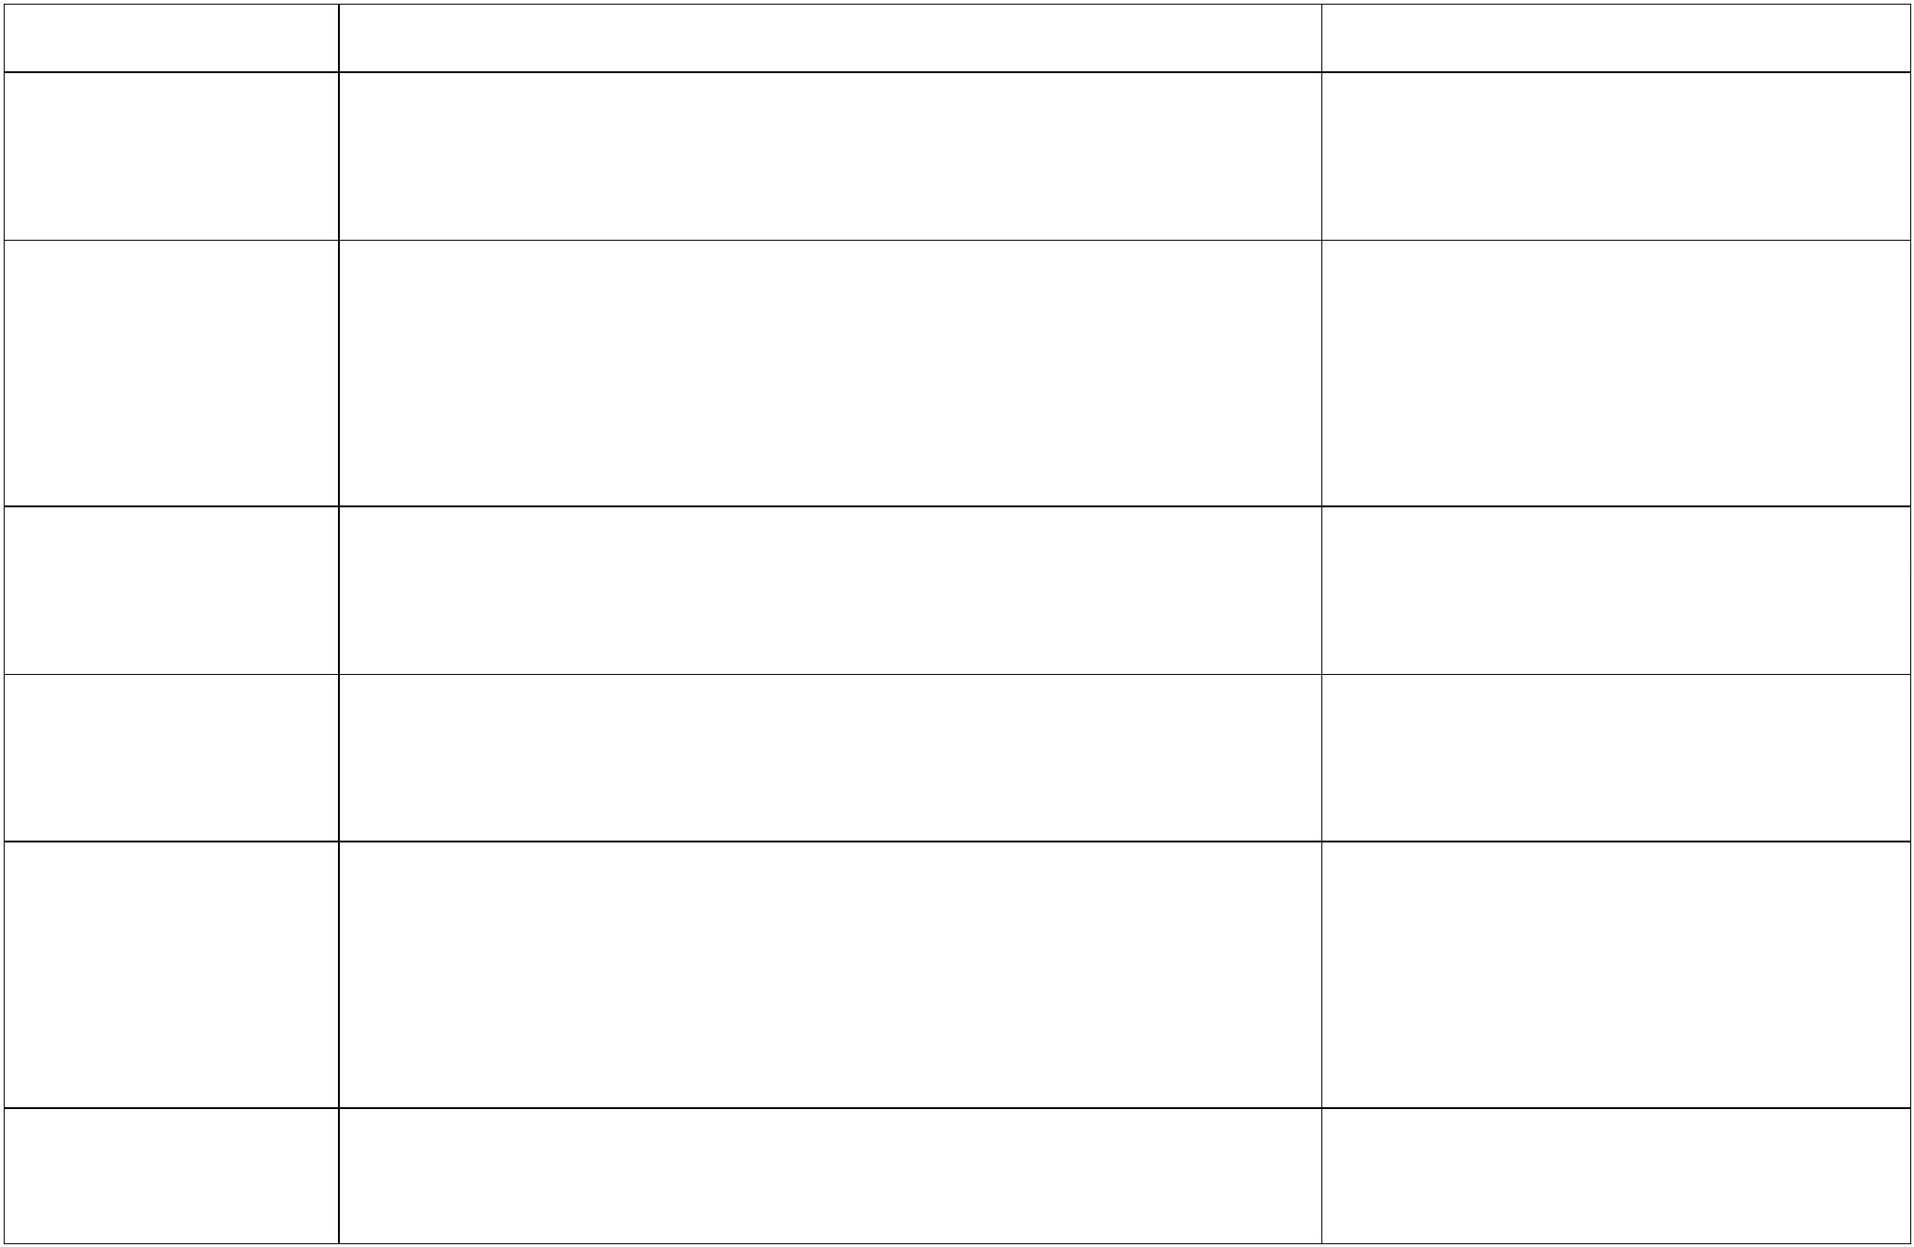ooxWord://word/media/image34.jpeg**7.0 USEFUL WEB RESOURCES**

Resource Name Function Weblink

Alibaba Trade Provides online marketing services for importers and [www.alibaba.com](http://www.alibaba.com/)Leads exporters. It is head quartered in Hong Kong and covers

more than 200 countries worldwide.

All Business An online media providing enterprenuers and growing [www.allbusiness.com](http://www.allbusiness.com/)Directory businesses with resources including, how-to articles,

business forms, contracts and agreements, expert advice,blogs, business news, business directory listings, productcomparisons, business guides and more.

BizEurope Provides trade leads, company information and contacts, [www.bizeurope.com](http://www.bizeurope.com/)

import and export information, individual country guides,a directory of World Trade centres and more.

Cargo Ports of the Provides links to web sites of ports and terminals around [www.hal-pc.org/~nugent/port.html](http://www.hal-pc.org/~nugent/port.html)World the world and contains information on vessel traffic and

cargo types that individual ports allow.

CBI CBI (Centre for the Promotion of Imports from developing [www.cbi.eu](http://www.cbi.eu/)

countries) is the agency of the Ministry of Foreign Affairsof the Netherlands. CBI's mission is to contribute tosustainable economic development in developing countriesthrough the expansion of exports from these countries.

Centre for Provides rules, regulations, tariffs, trade opportunities, [www.centretrade.com](http://www.centretrade.com/)International finance, management, transportation, resource and travel

ooxWord://word/media/image35.jpegooxWord://word/media/image37.jpegTrade information.

Euro Export An online service, provided by the European Commission, [http://exporthelp.europa.eu](http://exporthelp.europa.eu/)HelpDesk to facilitate market access in particular for developing

countries to the European Union.

Expo DataBase Online database containing about 20,000 trade shows and [www.expodatabase.com](http://www.expodatabase.com/)

exhibition dates worldwide with detailed exhibitionparticulars.

International ITC is the technical cooperation agency of the United [www.intracen.org](http://www.intracen.org/)Trade Centre Nations Conference on Trade and Development (UNCTAD)(ITC) and the World Trade Organisation (WTO) for operational,

enterprise-oriented aspects of trade development. The siteprovides global programs, advisory and training services,information sources, and tools and products.

Open Trade Gate OTGS is a one-stop information centre assisting exporters [www.opentradegate.se](http://www.opentradegate.se/)Sweden (OTGS) from developing countries with information on rules and

requirements in Sweden and the European Union. Theycover areas such as customs procedures and preferences,labelling, packaging, health and sanitary requirements.

The Trade Lead Provides international trade services for manufacturers, [www.tradezone.com](http://www.tradezone.com/)Zone importers/exporters, trade service business and

opportunity seekers. It includes import/export trade leads,International Trade Bulletin board, traders Web sites andweb site advertising.

33 | P a g e

ooxWord://word/media/image38.jpegTradeport An international trade web site funded by the Carlifonia [www.tradeport.org](http://www.tradeport.org/)

Export Assistance Centre and U.S. Department ofCommerce. It provides information on trade leads, marketand industry research, events and trade shows, tradetutorial and other information.

**8.0 USEFUL CONTACTS**

**8.1 Government Agencies**

|  |  |  |  |  |  |
| --- | --- | --- | --- | --- | --- |
| **Document** | **Institutions** | **Physical Address** | **Phone** | **Email** | **Website** |
| Veterinary Certificate | Veterinary Department | Mulungushi House Ridgeway Area, Lusaka | +260 21125 6679 |  |  |
| Quality Certificate |
| Health Permit | Ministry of Health | Ministry of Health Haile Selassie Avenue, Ndeke House, Lusaka, Zambia | +260 211 253 040–5 | [ps@moh.gov.zm](mailto:ps@moh.gov.zm) |  |
|  |
| CITES Certificate | Department of National Parks and Wildlife | Stand No. 1271, Kafue Road, Chilanga District | - | - |  |
| Phytosanitary (SPS) Certificate | Plant Quarantine and Phytosanitary Services (PQPS) | Mount Makulu Research Station, Chilanga District, Lusaka Province, Zambia | 077 0446402 | [pqps.infor@agriculture.gov.zm](mailto:pqps.infor@agriculture.gov.zm) | [www.pqps.gov.zm](http://www.pqps.gov.zm/) |
|
|
| Phytosanitary Certificate (Seed) | Seed Control and Certification Institute (SCCI) | Mount Makulu Road, Chilanga |  | infor@agriculture.gov.zm |  |
| Health Permit | Ministry of Health | Ministry of Health Haile Selassie Avenue, Ndeke House Lusaka Zambia | +260 211 253 040–5 | [ps@moh.gov.zm](mailto:ps@moh.gov.zm) | [www.moh.gov.zm](http://www.moh.gov.zm/) |
| Export Permit | Ministry of Agriculture - Agrio-business & Marketing Dept | Mulungushi House Ridgeway Area, Lusaka | 0211 254 645 | [infor@agriculture.gov.zm](mailto:infor@agriculture.gov.zm) | [www.agriculture.gov.zm](http://www.agriculture.gov.zm/) |
| Certificate of Origin | Zambia Revenue Authority | Revenue House, Kabwe Road, Lusaka | 0 211 381111 | [advice@zra.org.zm](mailto:advice@zra.org.zm) | [www.zra.org.zm](http://www.zra.org.zm/) |
| Phytosanitary (SPS) Certificate | Plant Quarantine and Phytosanitary Services (PQPS) | Mount Makulu Research Station, Chilanga District, Lusaka Province, Zambia | 077-0446402 | pqps.infor@agriculture.gov.zm | www.pqps.gov.zm |
|
|
| Health Permit | Ministry of Health | Ministry of Health | +260 211 253 040–5 | [ps@moh.gov.zm](mailto:ps@moh.gov.zm) | [www.moh.gov.zm](http://www.moh.gov.zm/) |
| Haile Selassie Avenue, Ndeke House |
| Lusaka |
| Zambia |
| Export Permit | Ministry of Agriculture - Agri-business & Marketing Dept | Mulungushi House Ridgeway Area, Lusaka | 0211 254 645 | [infor@agriculture.gov.zm](mailto:infor@agriculture.gov.zm) | [www.agriculture.gov.zm](http://www.agriculture.gov.zm/) |
| Mineral Export Permit | Ministry of Mines and Minerals Development | New Government Complex, Kamwala, Lusaka | 0 211 237306 | [info@mmmd.gov.zm](mailto:info@mmmd.gov.zm) | [www.mmmd.gov.zm](http://www.mmmd.gov.zm/) |
| Security Clearance Permit | Zambia Police Service | Area where the Mineral is mined | - | - | - |
| Export Permit | **OR** Zambia Medicines Regulatory Authority | Off Kenneth Kaunda International Airport Road | 0211 432 350 | [pharmacy@zamra.co.zm](mailto:pharmacy@zamra.co.zm) | [www.zamra.co.zm](http://www.zamra.co.zm/) |
|
| **OR** Zambia Environmental Management Agency | Corner Church and Suez Roads, Lusaka | 0211 254 023 | info@zema.org.zm | [www.zema.org.zm](http://www.zema.org.zm/) |
|
|
| Clearance Certificate | Forestry Department |  |  | [info@mgee.gov.zm](mailto:info@mgee.gov.zm) |  |
|
| Phytosanitary Certificate | Plant Quarantine and Phytosanitary Services | Mount Makulu Research Station, Chilanga District, Lusaka Province, Zambia | 077-0446402 | [pqps.infor@agriculture.gov.zm](mailto:pqps.infor@agriculture.gov.zm) | [www.pqps.gov.zm](http://www.pqps.gov.zm/) |
|
|
| Certification mark | Zambia Bureau of Standards. | Lechwe House Freedom Way- South End, Lusaka | +260 777 764 421 | info@zabs.org.zm | <http://www.zabs.org.zm/> |

**8.2 Producer Associations**

**8.2.1 Floriculture and Horticultural Sectors**

Zambia Export Grower's Association (ZEGA) Airfreight Village

Lusaka International Airport P O Box 310245 Lusaka, Zambia Tel: +260-1-271166 Fax: +260-211 -271167

Email: zega@zegaltd.co.zm or zega@zamnet.zm Website: www.zambiaexportgrowers.com

**8.2.2 Handicrafts and Curios Sector**

Handicrafts Association of Zambia Plot L/2085 Airport Road, Chelstone Lusaka, Zambia

Mobile: +260 -977- 796 332 Fax: +260- 211- 221 949

Email: jbkosa@gmail.com or cchilongo@yahoo.com

**8.2.3 Leather and Leather Products Sector**

Leather Industries Association of Zambia (LIAZ) P.O. Box 32922 Lusaka, Zambia

Tel: +260-211-222210/225797

Zambia Crocodile Association P.O. Box 38267 Lusaka, Zambia

Tel: +260-211-213272

Email: [kalimba@zamsat.net](mailto:kalimba@zamsat.net)

**8.2.4 Manufacturing**

Zambia Association of Manufactures (ZAM) Stand No. 2374, Showgrounds P.O. Box 424 Private Bag E891 Lusaka, Zambia

Tel: +260-211-253696 Fax: +260-211-253693 Email: zam@zamnet.zm

**8.2.5 Primary Agriculture**

Agribusiness Forum 120 kudu road, Kabulonga P.O.Box 32758 Lusaka, Zambia

Tel: +260-211-262936 Fax: +260-211-262950 Email: inf@abf.org.zm

Organic Producers Association of Zambia (OPPAZ) 14 Leopards Hill Road, Kabulonga P.O. Box 35317 Lusaka, Zambia

Tel: +260-211-263070 Fax: +260-211-265208

Email: oas@organic.org.zm or mchitalu@organic.org.zm

Zambia Coffee Growers Association P O Box 35388 Lusaka, Zambia

Tel: +260-211-286447 Fax: +260-211-287654 Email: jtaguma@zcga.co.zm

Zambia National Farmers Union (ZNFU) Head office, Farmers Village Tiyende Pamodzi Road, Showgrounds P.O. Box 30395 Lusaka, Zambia

Tel: +260-211-252649/255769/257958/254431/0977-722686 Fax: +260-211-252648

E-mail: znfu@zamnet.zm Website: www.znfu.org.zm

**8.2.6 Wood and Wood Products**

Lumber Millers Association of Zambia Plot 3283A, Mungwi Road Private Bag E891 Lusaka, Zambia

Timber Producers Association Malche House Room 2, Off Chandwe Musonda Road P.O. Box 3324 Lusaka, Zambia

Tel: +260-211-221346 Fax: +260-211-226270

**8.3 Other Trade Support Associations**

Small Scale Industries Association of Zambia (SSIAZ) Kwacha House Annex, Cairo Road P.O. Box 365 Lusaka, Zambia

Tel: +260-211-234072 Fax: +260-211-234073

Email: ssiaz2005@yahoo.com

Zambia Chamber of Small and Medium Business Association (ZCSMBA) Showgrounds, Great East Road

P.O. Box 32932 Lusaka, Zambia

Tel: +260-211-253372/254855 Fax: +260-211-253013 Email: hrdp@zamnet.zm

Association of Women in Mining P.O. Box 50550 Lusaka, Zambia

Tel: +260-977-76926

Email: nanga@africamail.com

Zambia Association of Chambers of Commerce and Industry (ZACCI) Lusaka Show Grounds

P.O. Box 30844 Lusaka, Zambia

Tel: +260-211-252483 Fax: +260-211-253020

Email: secretariat@zacci.co.zm Website: <http://www.zacci.org.zm>

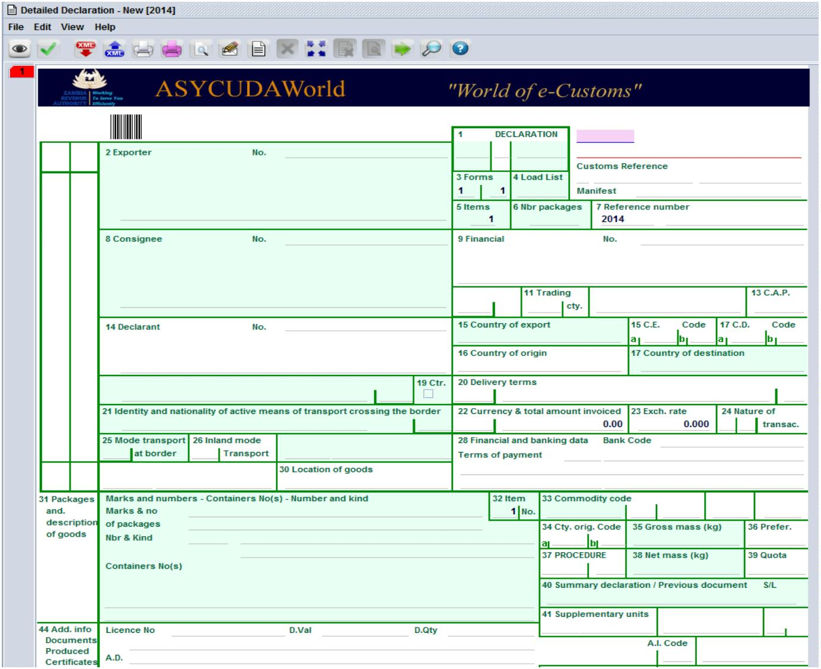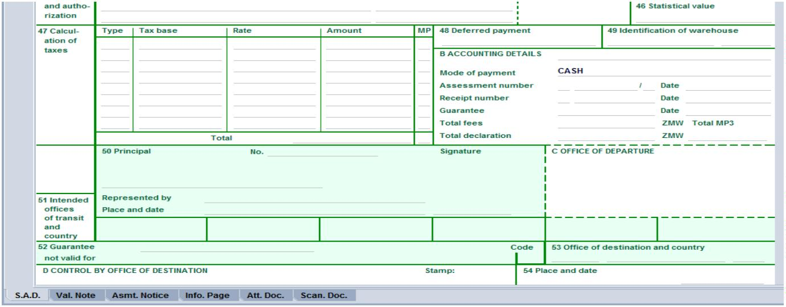**9.0 APPENDICES**

**9.1.0 Selected Sample Export Documents**

**Appendix I: Customs and Excise Document Form CE 20**

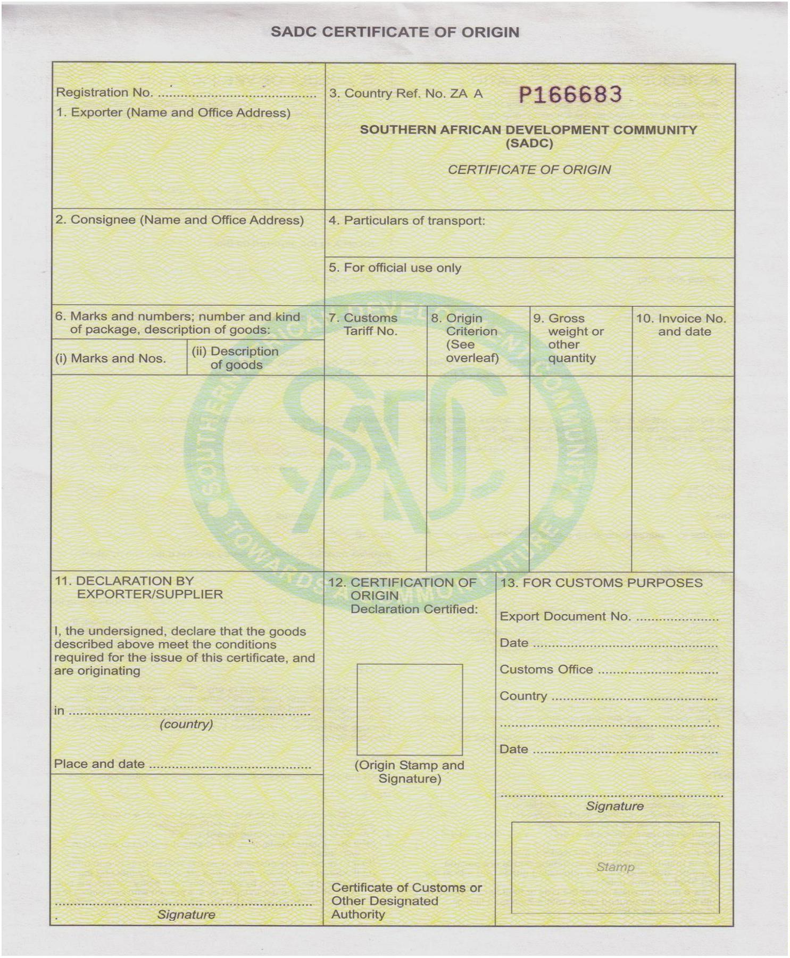**APPENDIX II: SADC Certificate of Origin**

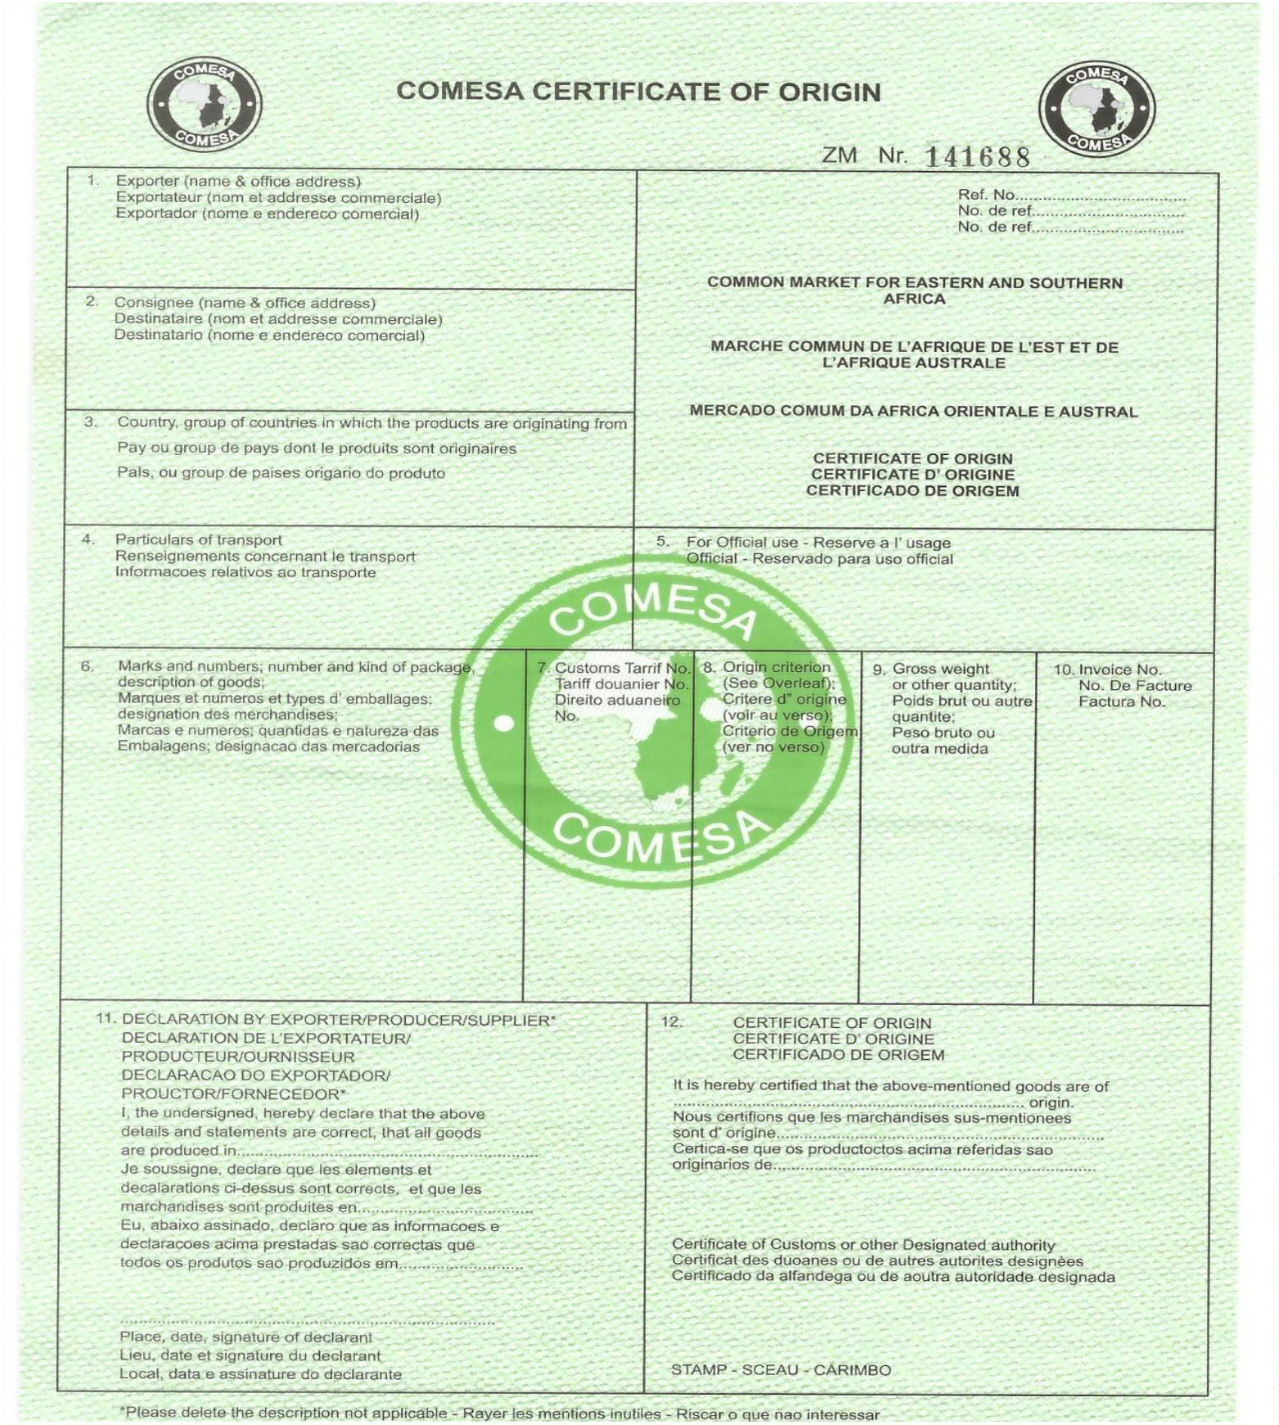**APPENDIX III: COMESA Certificate of Origin**

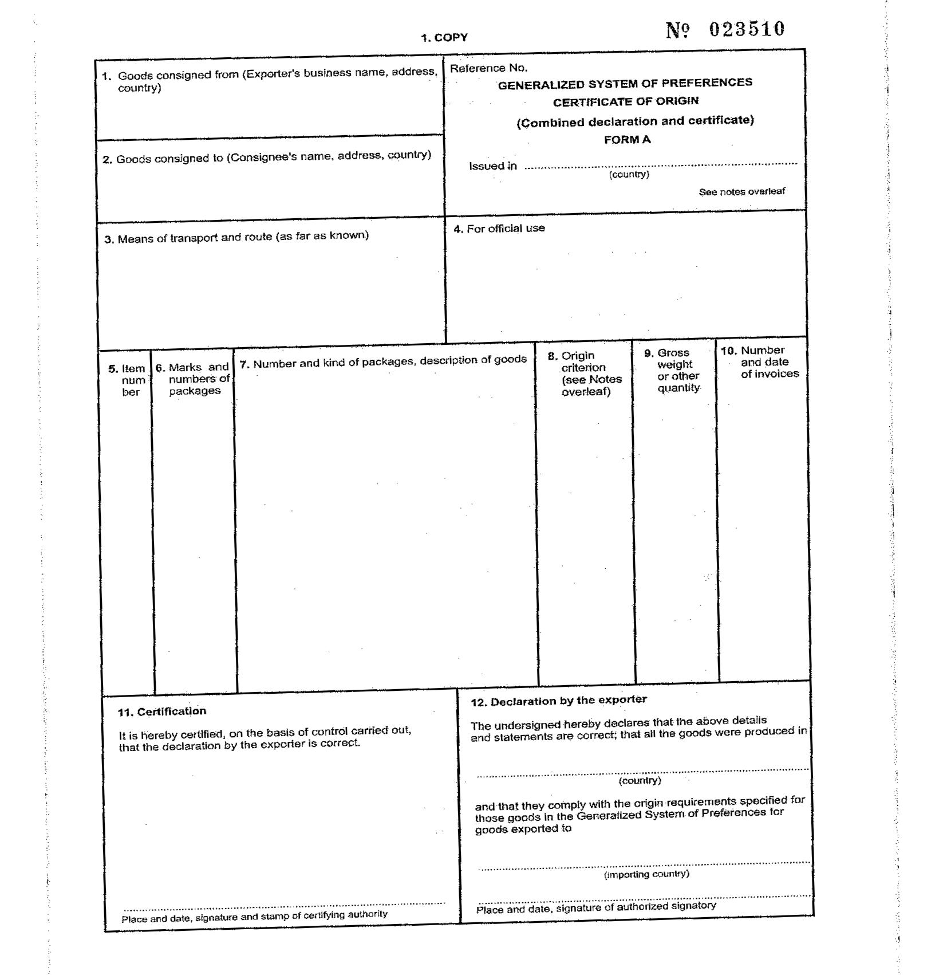**APPENDIX IV: Generalized System of Preferences Certificate of Origin**

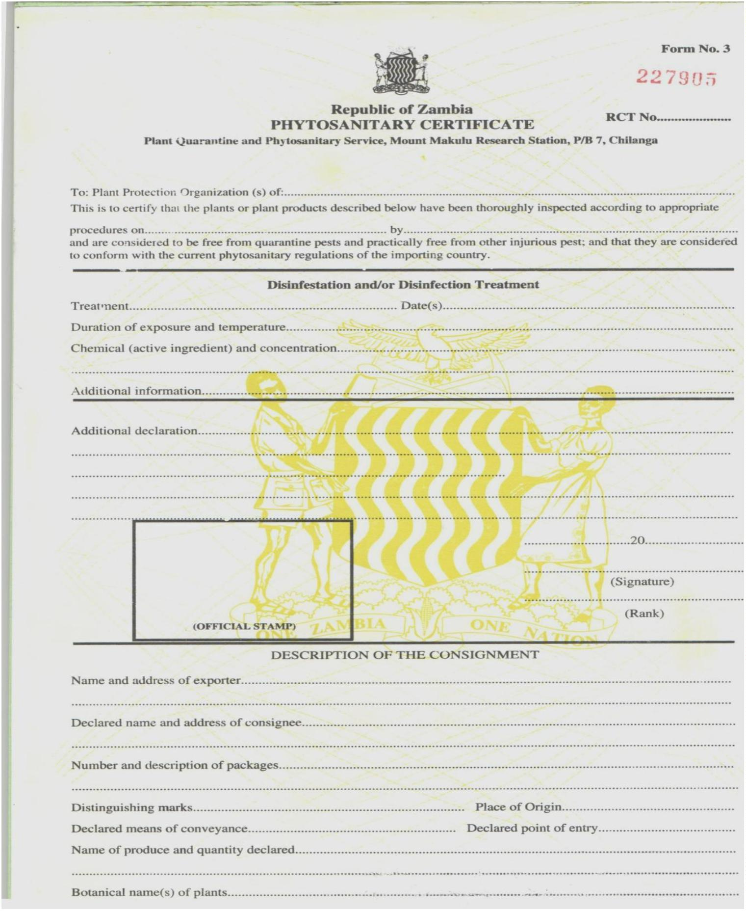**APPENDIX V: Phytosanitory Certificate**

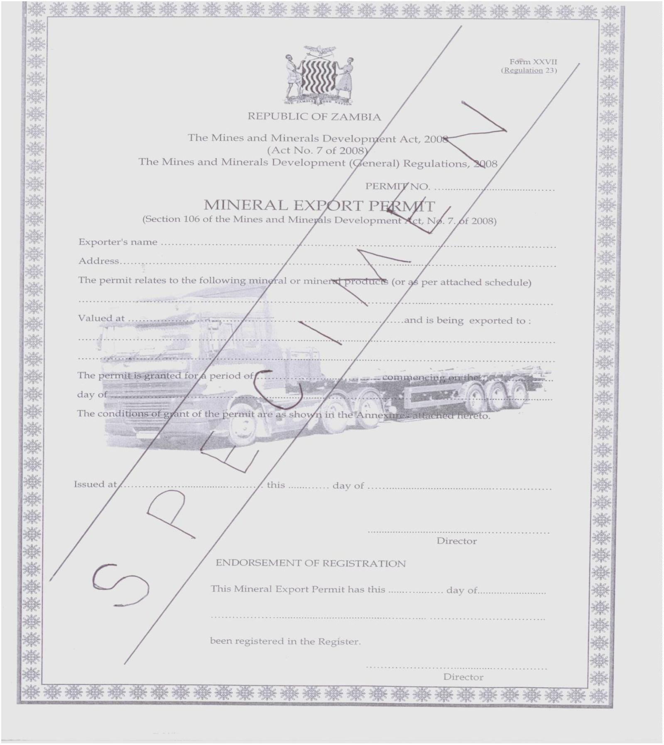**APPENDIX VI: Mineral Export Permit**

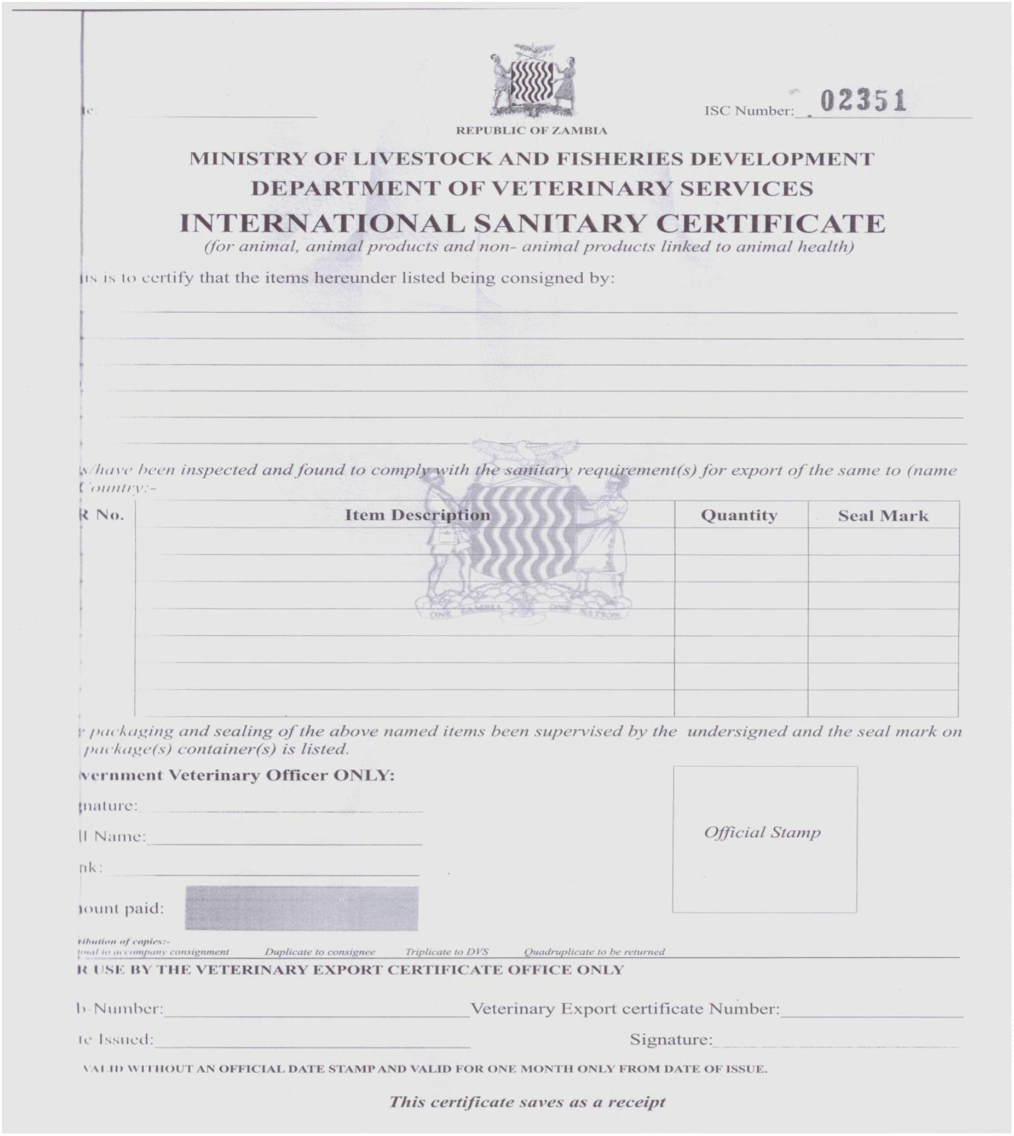**APPENDIX VII: International Sanitory Certificate**

**(for animal, animal products and non-animal products likened to health)**

**APPENDIX VIII: Dangerous Drugs Licence**

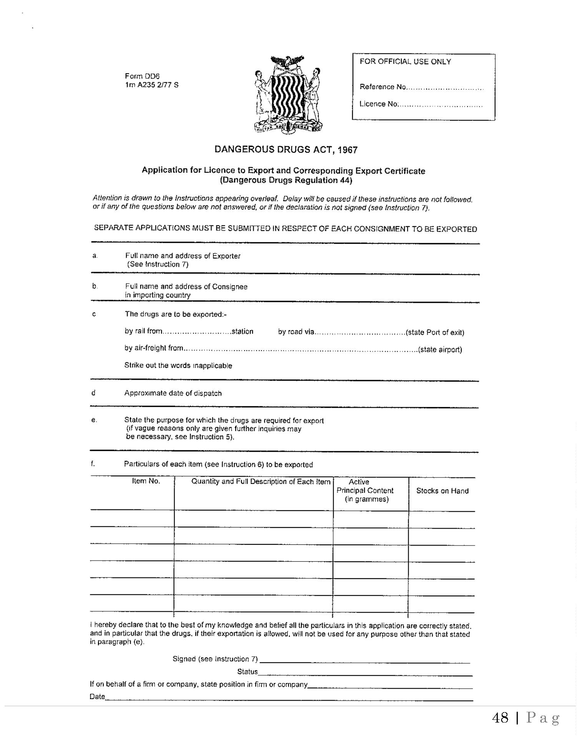

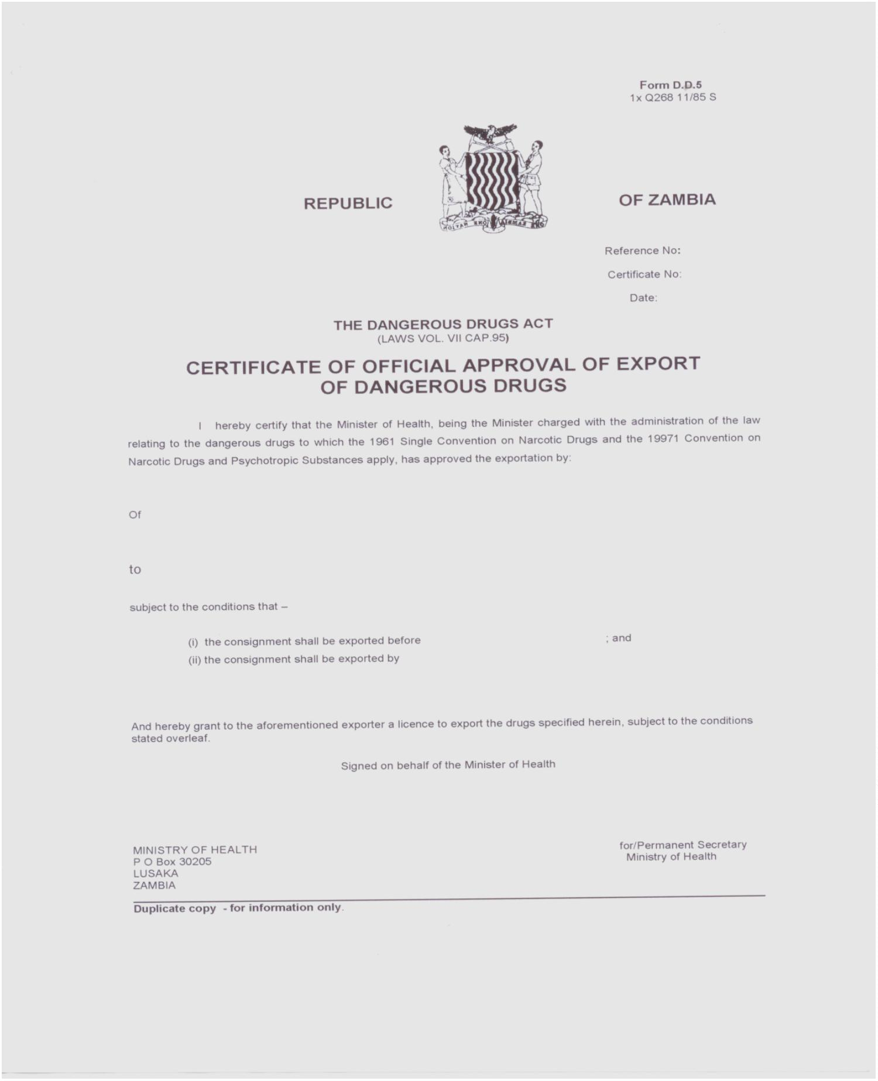**APPENDIX IX: Dangerous Drugs Export Certificate**

**10.0 REFERENCES**

Bank of Zambia. (2013) Bank of Zambia Balance of Payments Monitoring Guide,Version 3. Lusaka. Zambia

Export Board of Zambia and International Trade Centre (2001). Trade Secrets- TheExport Answer Book for SMEs. Lusaka: ITC/EBZ, 2000,136 p.

Edwin Hinkeman, G. (1947) Dictionary of International Trade: handbook of theglobal trade community, 7th ed. California, USA. Word Press.

Zambia Development Agency (2022). Exporter Audit Report. Lusaka, Zambia

Zambia Development Agency (2019). 2019 Directory of Zambian Exporters. Lusaka,Zambia

**Head Office**

The Director General Zambia Development Agency Privatisation House, Nasser Road P.O. Box 30819 Lusaka, Zambia

Tel: +260-211-223859 / 220177 / 222858 Fax: +260-211-225270 Email: info@zda.org.zm Website: www.zda.org.zm

The Director General Zambia Development AgencyPrivatisation House, Nasser RoadP.O. Box 30819 Lusaka, Zambia

Tel: +260-211-223859 / 220177 / 222858Fax: +260-211-225270 Email: info@zda.org.zm Website: www.zda.org.zm

**Town Office**

Information Resource CentreKwacha House AnnexP.O. Box 30064 Cairo Road Lusaka, Zambia

Tel: Tel +260 211 224790