directory of zambian exporters

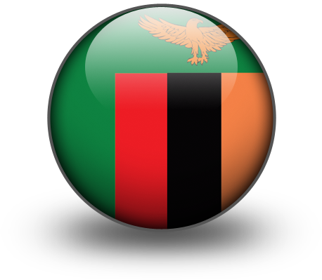

Zambia Development Agency

ANIMAL PRODUCTS

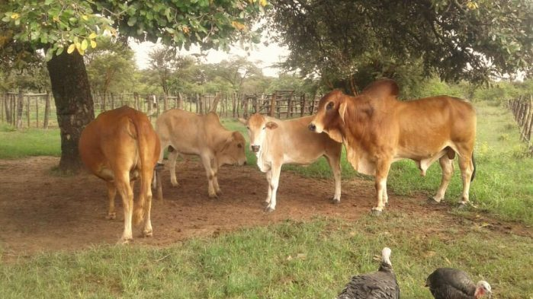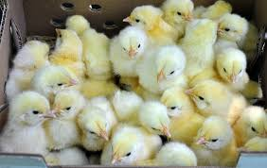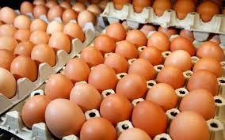
Industry Structure
The Animal Products sub sector covers products derived from animals, which include fresh eggs, fresh fish, dried fish, milk and milk products and beef and beef products. Others are game meat, game trophies, crocodile meat, dressed chickens, pork and pork products, veal, mutton and edible and ornamental fish.

CONTACTS

Company | Address | Tel/ Email | Export Products
Zambeef | Plot 4970, Manda Road, Industrial Area, Lusaka | Tel: +260 211 369 000  Fax: +260 211 369 050  Email: justok@zambeef.co.zm  Website: www.zambeefplc.com | Fertilized eggs, fresh eggs, frozen chickens, day old chicks, beef, pork and stock feed
Hybrid | Chamba Valley, Chelston P. O. Box 310097 Lusaka | Tel: +260 211 284323/ +260 211 283626  Email: enquiries@hybridpoultryfarm.com  Website: http://hybridpoultryfarm.com | Fertilized eggs and day olf chicks
Ross Breeders | Great East Road, P.O. Box: 36468, Lusaka, Zambia | Tel: +260 962 757 610  Email: colin@rossafrica.com  Website: http://rossafrica.com | Fertilized eggs and day old chicks
Daisy Meats | Off Kafue Road, Shimabala, Chilanga | Tel:+260977492727  Email: daisymeats@dsdinvestmentsltd.com | Pork and frozen chickens
Majoru | Makeni factory outlet, Bonaventure Area, Chikupi Road, PO Box 36518, Lusaka | Tel: +260 211 845658  Email: mandir@majoru.co.zm | Assorted meat products
Tiger Chicks | 8537, Mwembeshi Road, Light Industrial Area, Lusaka | Tel: +260 211 286262 | Fertilized eggs, day old chicks and stock feed
Kachema | Makeni Factory, Old Makeni Road, Lusaka | Tel: + 260963 579850/0+2600971 877700  Email: md.kachema@gmail.com | Assorted meat products
Lake harvest | 7228 Kachidza, Industrial Area, Lusaka | Tel: +260 211 287443, +260 965 078215  Email: kmakunike@lakeharvest.com | Fresh fish
Legana Meat Products | Alick Nkhata Road, Lusaka | Tel: +260 0979650591 / +26097 9332911 | Assorted meat products
Galaunia Farms | Nampundwe Rd, Chinika, PO Box 30089, Lusaka | Phone: +260 21 128 6165  Email: ceo@galaunia.co.zm | Assorted meat products and milk
Yalelo | Plot 6981 Mukwa Road, (Cnr. Lumumba Road) Light Industrial Area, Lusaka | Phone: +260 211 24 6060, +260 962 322428  Email: info@yalelo.com sales@yalelo.com | Fresh fish
Capital Fisheries | P.O. Box 34650 Plot 6980 Katanga Road, Light Industrial Area, Lusaka | Tel: +260 969 111775, +260 966 040805 Email: info@capfish.com | Fresh fish
Bienne Donne | New Kasama, Lusaka | Tel: +(260)961011023, +(260)971552080, +(260)96 5459901  Email : biendonne@zamtel.zm info@biendonnefarm.com | Quails and quail eggs
Zambezi Ranching | Ngwerere Road, Lusaka | Tel: +2602110262888 +260966860531  Email: graham@zrczambia.com | Assorted meat products

BUILDING MATERIALS

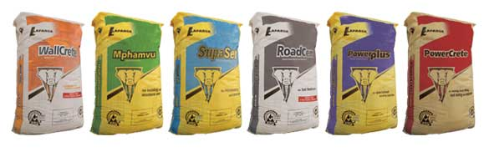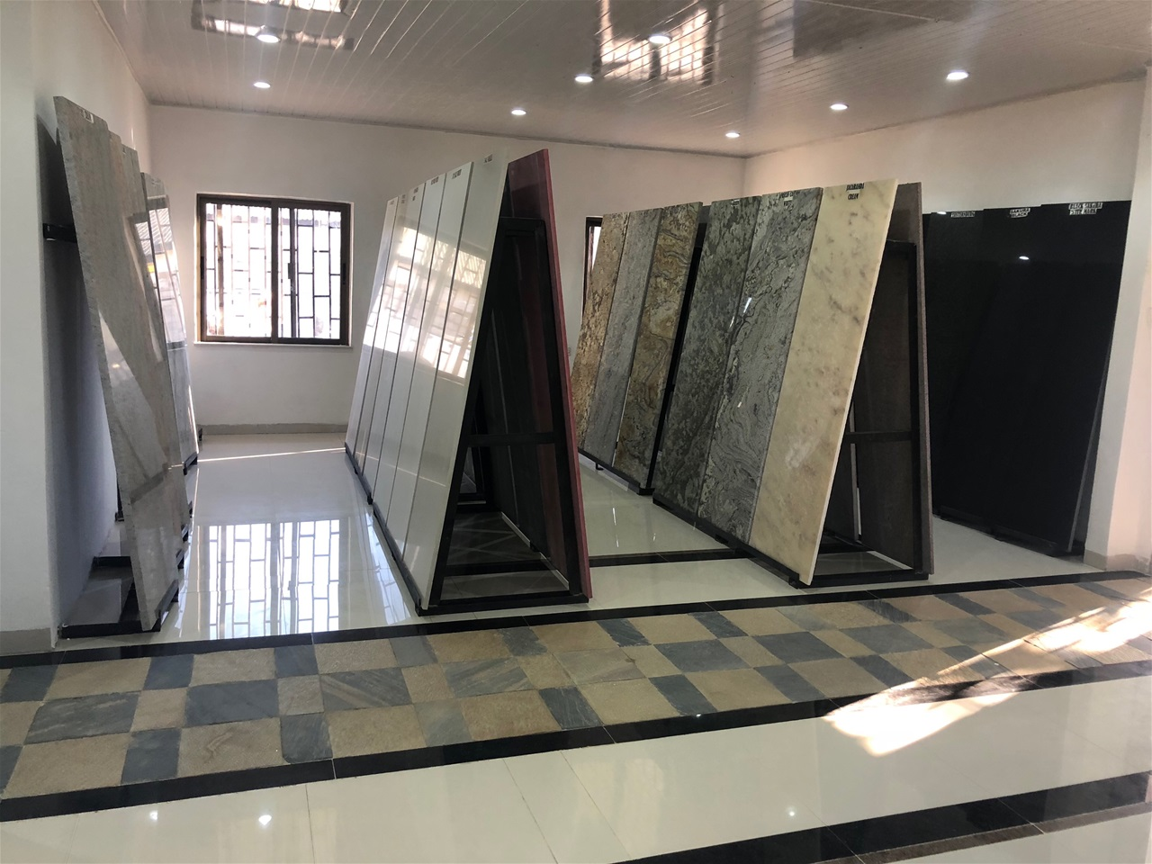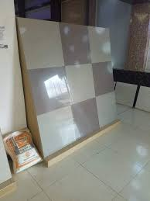

Industry Structure

The Building Materials sector includes products such as asbestos pipes, asbestos roofing sheets and tiles, portland composite cement, OPC cement, ceramic product, asbestos high pressure pipes for sewerage systems, metal door frames, window frames and other related building products. It also includes quarrying and crushing of aggregates of assorted size distributions.

The main export markets for building materials were India, Congo Dr, Singapore, Malawi, Burundi, Hong Kong, Zimbabwe, United States of America, South Africa and China. The main export products during the period under review were Articles of stone or other mineral substances, Portland cement, Cement clinkers, Prefabricated structural components for building, Natural steatite, Prefabricated buildings, Prefabricated buildings, Ceramic flooring blocks, Granite and Ceramic wares for laboratory.

The main players in this sector were Gemcanton Investments, Kagem Mining Limited, Zambezi Portland Cement Limited, Dangote Industries Zambia Limited, Flemsim Clearing And Forwarding, Lafarge Cement Zambia Plc, Sinoma International Engineering, Reload Logistics And Trading Limited, Kazumba Investments Limited and Polymer Concrete Industries.

BUILDING MATERIALS company contacts

COMPANY | ADDRESS | TEL/ EMAIL | Export Products
Lafarge | Head Office, Farm No.1880, Kafue Rd, P.O. Box 32639, Chilanga, Lusaka | Tel: +260 211367415  +260 211 367 400  +260 211 367 600  E-mail: enquiries.zambia@lafargeholcim.com | cement
Dangote | SR.Chief Chiwala Area, Lonshi Road, Masaiti District, Ndola | Tel: +260 971 260 666  Email: peter.lazarus@dangote.com sylvester.kasonde@dangote.com | Cement
Mpande Limestone Limited - Sinoma Cement | Off Kabulonga Road Lusaka Zambia 10101 Zambia | Tel: +260211287788-91  Email: sinomalouis@gmail.com | Cement and assorted building materials
Micmar/ Kroup Wood | Box 35239, Lumumba Rd, Lusaka | Tel: +260-211-287788,  Email: mkroupnik@micmar.co.zm sales@micmar.co.zm | Assorted building materials
Neelkanth Lime | Plot 1263/M, Masaiti Area, Chilngwa Road, P.O. Box 71035, Ndola | Tel: +260 212 671661  Email: girish.ayar@neelkanthlime.com  Website: www.neelkanth-africa.com | Lime
Handyman’s Lime | Masaiti Area, Chilngwa Road, Ndola | Tel: + 260 961 024420  Email: Sylvester.ngoma@gmail.com | Lime
Wonderful Group |  |  | Assorted building materials

CHEMICAL AND PHARMACEUTICAL PRODUCTS

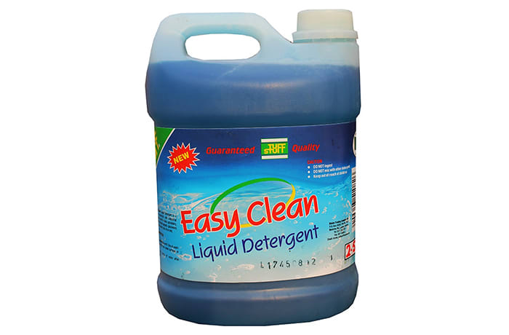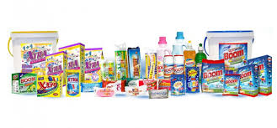

Industry Structure
The Chemical and Pharmaceutical products sector comprises of products such as medicines, sulphuric acid, explosives/detonators, detergents, cosmetics and gases (oxygen, hydrogen and argon), automotive batteries, soaps and detergents, ferrosilicon, talcum powder, polyvinyl acetate and gloss paints, fertilizers and industrial/mining batteries.

The major players in this sector include Chambishi Copper Smelter Limited, Mopani Copper Mines Plc, Trade-Kings Limited, Sl Solutions Limited, Ael Zambia Plc, Reload Logistics And Trading Limited, Bridge Shipping Zambia Limited, Cargo Management Logistics, Kansanshi Mining Plc and Samfuel Limited. The top export products are Sulphuric acid, Sulphur of all kinds, Washing and cleaning preparations, Other organo-sulphur compounds, Other prepared explosives, Double salts and mixtures of calcium nitrate and ammonium nitrate, Sodium sulphites, Copper oxides and hydroxides and Soap.

CHEMICAL AND PHARMACEUTICAL PRODUCTS CONTACTS
COMPANY | ADDRESS | TEL/ EMAIL | Export Products
Gaxo Smith Kline | 40 Macquarie Street, Maddocks Building, BartonACT 2600, Canberra | Tel: +61470039936  Email: zamcanhc@gmail.com | Assorted pharmaceutical products
Nasla | 31-33 Rua Alanmenda do Principe real, Miramar,  P.O.Box 1496, Luanda | Tel: + 244-222-447491  Email: zambianembassyluanda@yahoo.com | Cosmetics
Orica | 469 Avenue Moliere,  1050 Brussels | Tel: + 32-2-3435649  Email: gov@zebru.org | Explosives
African Explosives (AEL) | Zambia House,  1118 Queens Road, The Main Mall  P.O.Box 362, Gaborone | Tel:+267-3951951  Email: zamhc@work.co.bw | Explosives
Plascon | 20 Damascus Street, off Syria Street, Mohandeseen, Cairo | Tel: + 20-2-376102881  Email: zamcairo@gmail.com zambiacairo@gmail.com | Paint
Trade Kings | Zambian House, 48 Kwame Nkruma Ave,  RO. Box 4698, Harare | Tel: + 263-4-773777  Fax: + 263-4-773782  Email: zambiae@mweb.co.zw | Detergents and soaps
Vitafro Limited | P O Box 71767, Ndola | Fax: +260 -212 -614692  Tel: +260 -212- 610497/8  E-mail: vitafro@coppernet.zm | Cosmetics

ELECTRICITY
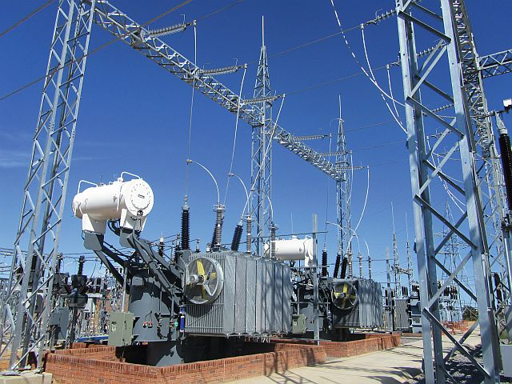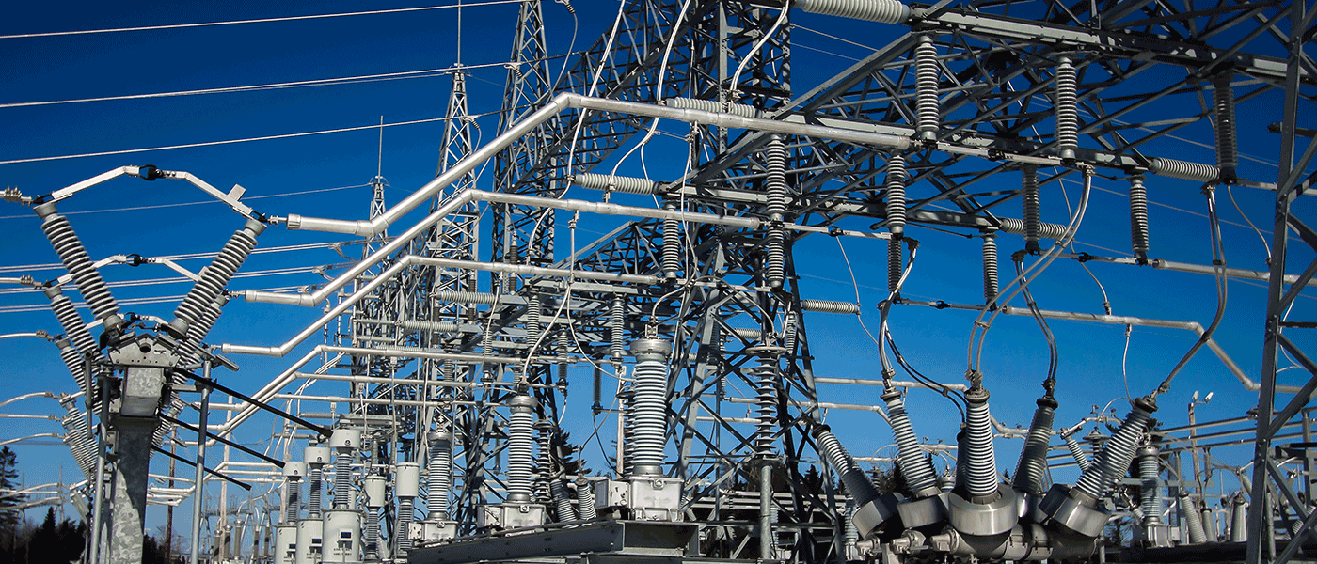
Industry Structure

The major distribution networks falls under the Zambia Electricity Supply Corporation (ZESCO) the national electricity utility, which was successfully commercialised in 2005. The corporation operates and maintains a high voltage transmission system. It is also responsible for all electrical power imports and exports in the country and provides retails services to all but the largest mining customers on the Copperbelt.
The electricity supply industry in Zambia mainly comprises of a vertically integrated state utility, ZESCO, and an energy service company, Copperbelt Energy Corporation (CEC) that purchases power from ZESCO and supplies it to the mines. In addition, Lunsemfwa Hydro Power Company, an independent power producer and some small- scale solar based energy service companies supply power to some rural areas.

The exporter of electric energy from Zambia is ZESCO. Exports in the sector have increased due to the increased generation capacity resulting from continued investments in the sector.

The main export markets included the Democratic Republic of Congo, Namibia, Tanzania, Botswana, Zimbabwe and Mozambique.

ELECTRICITY COMPANY CONTACTS

COMPANY | ADDRESS | TEL/ EMAIL | Export Products
ZESCO | Great East Road, Stand No.6949, P O BOX 33304, Lusaka | Tel: 260 211 361111  Email: zesco@zesco.co.zm | Electricity
CEC | 23rd Avenue, Nkana East, P.O. Box 20819, Kitwe | Tel: + 260 212 244274 | Electricity
Maamba Collieries (Power Generation) | Head Office  PO Box 99  Maamba  Corporate Park,  Plot No. 20849 Alick Nkhata Road, P.O. Box 31197  Lusaka, | Tel : + 260 211 256010 | Coal/ Electricity
Kafue Gorge Regional Training Centre | P.O. Box 32774, Lusaka P.O. Box 35 Namalundu, | Tel: +260 211 363947 / +260 211 371007/8 / +260 976 668 843; +260 966 940 645; +260 953 821 697  E-mail: info@kgrtc.org.zm or frontdesk@kgrtc.org.zm or info.kgrtc@gmail.com  Website: http://www.kgtrc.org.zm | Energy sector training services

ENGINEERING AND FOUNDRY PRODUCTS
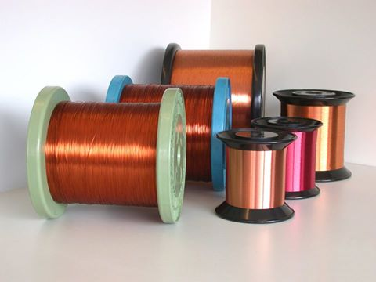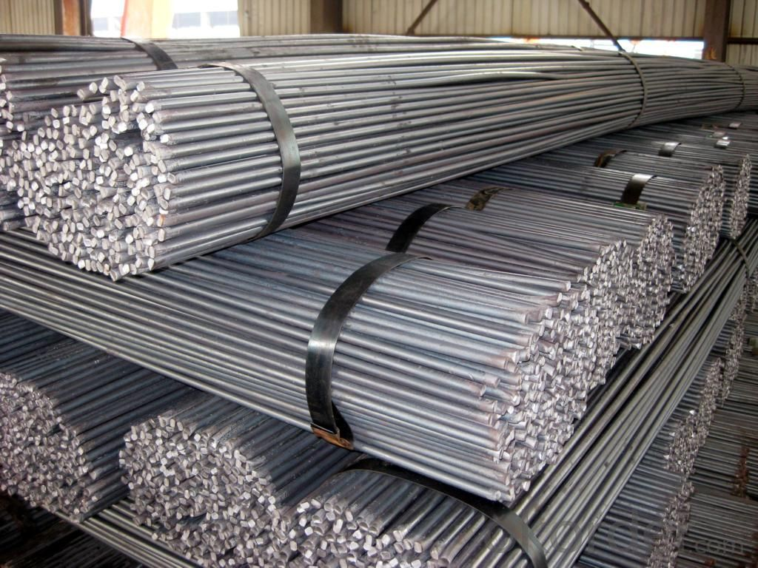

Industry Structure

The Engineering sub-sector is divided into three specific groups comprising semi finished and finished non-ferrous metals, finished metals and other engineering products. Specific products include copper wire, telephone cables, aluminum cable wire, bare wire, copper rods, flat metal sheet, drums, building wire, power cables, steel wire and carbon brushes.
The Engineering sub-sector is dominated by Metal Fabricators Of Zambia Limited, Weir Minerals Central Africa, Universal Mining Chemical Industries, Plr Projects Zambia Limited, Sandvick Mining And Construction, Epiroc Zambia Limited, Southern Africa Ferro Alloys Limited, Reba Industrial Corporation Limited and Ferro Alloys Corporation Limited.
The main destinations of these products were Congo Dr, South Africa, Zimbabwe, Tanzania, Botswana, Malawi, Kenya, United Arab Emirates, India and Italy.

ENGINEERING & FOUNDRY PRODUCTS COMPANY CONTACTS

COMPANY | ADDRESS | TEL/ EMAIL | Export Products
ZAMEFA | 1400 Figov Road, Luanshya, Copperbelt  20996 Kafue Road, Makeni, Lusaka | Tel: +260 211 274300, +260 212 512637  Email: luanshya.sales@zamefa.com  lusaka.sales@zamefa.com | Copper cables
Neelkanth | Plot 1263/M, Masaiti Area, Chilngwa Road, P.O. Box 71035, Ndola | Tel: +260 212 671661  Email: girish.ayar@neelkanthlime.com  Website: www.neelkanth-africa.com | Copper cables
Matalloy | Post Box No 10908, Plot No:1320, Chachacha Road,  Luanshya | Tel: +260 212 510 536 +260 212 510 984  Email: info@matalloy.com | Ferro Silicon and Silico Manganese
Zalco/ Metalco | 5110, Lumumba Road,Lusaka,Lusaka | Tel:+ 260-211-286771 | Industrial Non Ferrous Scrap Metal: Aluminium, Copper, brass, Bronze, Zinc, Lead. Copper Concentrates,Copper Ore, Malachite, Copper Blister
BSI Steel | Plot 5113/5114, Cnr Lumumba Rd & Bambo Rd, Light Industrial Area Lusaka, 1100 | Tel: +260 211 222112 / 223625 | Fax: +260 211 227 368 | Mobile: +260 96 323 8645  Email: andrew.brett@bsisteel.com | Steel, IBR and Corrugated sheets
MMI Steel | Katanga Road, Industrial Area, Lusaka | Tel: +260 21 184 6098, +260 21 128 7266  Email: sales@mmisteelszambia.com | Tanks, Steel, IBR and Corrugated sheets
Class Econ | Plot 7173 Mukatasha Rd Light Industrial Area, P.O.Box 35532, Lusaka, Zambia | +260 21 184 0164  +260 21 184 0166 | Steel, IBR and Corrugated sheets
Sunshare | plot 5147,waashama road (2.96 mi) P.O.Box 37886  Lusaka, Zambia | Tel: 0978960333  Email:  sunshareagent@126.com  Website: http://www.sunshare.biz/ | various types of Building Materials (roofing, aluminium, doors, kitchen units, wardrobes , sofas ) and construction.
Goodtime Steel | PLOT No. 33811, Mungwi Road,  Heavy Industrial Area,  Lusaka Zambia | Tel: +260-01-244481/4  Email: goodtimesteel888@gmail.com  Website: www.gtsteel.co.zm | Steel, IBR and Corrugated sheets

FLORICULTURE AND HORTICULTURE
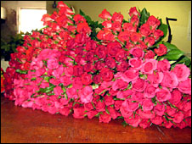
Industry Structure

The Zambian Floriculture sector is largely related with summer flowers and cut flowers. Supported by climate conditions that favor growth, production of fresh flowers has steadily been increasing, with floriculture becoming one of Zambia’s leading export subsectors. Cut flowers comprise mainly roses which are largely for the export market. Zambia’s horticulture and floriculture sub sectors mostly comprise commercial companies which grow mainly for the export market and small scale farmers who mainly grow for the domestic market. Most of the export growers are members of ZEGA and implement the ZEGA code of practice.
The major export markets for Zambia’s floricultural products in the period under review were Netherlands, Germany, United Kingdom, Belgium and South Africa. The top markets for Zambia’s horticultural products were Congo Dr, Germany, United Kingdom, South Africa, China, Netherlands, Botswana, France, Zimbabwe and Tanzania.

FLORICULTURE & HORTICULTURE PRODUCTS COMPANY CONTACTS

COMPANY | ADDRESS | TEL/ EMAIL | Export Products
Khal Amazi | Khal Amazi Ltd, Great East Road Chongwe, Lusaka | Tel: + 260965740080  Email: greg@khalamazi.com | Cut Flowers
Scimitar | Great East Road, Chongwe, Lusaka | Tel: + 260979476587  Email: John.Griffiths@scimitarfarming.com | Summer Flowers
Esquire Roses | Chisamba, Central Province  P. O. Box 38491  Lusaka | Tel: +260 977 862723 /+211 213682/213319/ +211288051/  Email: phiri_boniface@yahoo.com  esqexports@zamtel.zm | Cut Flowers
Enviro Flo | Enviro Flor  Kasisi Road  Chongwe | Tel: +211 233819/233834  +26095 701371/ +260977 344999  Email: admin-env-flor@iwayafrica.com  env-flor@zamnet.zm | Cut Flowers and Fresh vegetables
York | York Farm, Kafue Road, Lusaka | Tel: +260966861934  Email: sriram@yorkfarm.co.zm | Cut Flowers and Fresh vegetables
Hortil | Hortil Limited, Chisamba, Central Province | Tel: +260211214732 /+260211214732/260977 818949/+260966620764  Email: wenham@coppernet.zm | Cut Flowers and Fresh vegetables
Tuzini Farms | Plot No. 12530 Chikumbi Road Chisamba, Lusaka | Tel: + 26097 8320593  Email: sales@tuzinifarms.com | Fresh vegetables

GARMENTS AND TEXTILES INDUSTRY

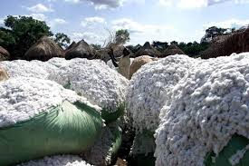

Industry Structure

The Zambian Textiles and Garments Industry is largely cotton based and encompass cotton ginning, spinning, weaving, dying and printing. Products from the textiles and garments subsectors include cotton lint, cotton yarn, acrylic yarn, loom state cotton fabric, African prints (Chitenge) poly/cotton fabric, polyester fabric, poly/viscose fabric, cotton canvass fabric, terry toweling, bed linen, kitchen linen, polypropylene cloth and bags, cotton and nylon ropes and twine, blankets, polythene bags, fishing nets, tents and tarpaulins. The common garments include; hospital uniforms, security uniforms, industrial uniforms, dust coats, shirts, trousers, overalls, traditional African attire and embroidery, casual wear, t-shirts and work suits.

The main exporters of garments were Bestnet Limited, Boart Longyear, Portmores Investments Limited, Amalgamated Dress, RSS Treasurers and Crafts and Grafax Cotton Zambia Limited. While the top exporters of textiles were Sakiza Spinning Limited, Mri Agro Zambia Limited, Lamasat International Limited, Mpala Warehousing and Logistics, Gourock Ropes Canvas, Polythene Products, Sack Twine Manufucturing Limited and Central Clothing Factory.
The major export markets for Zambia’s garment products in the period under review were Congo Dr, Malawi, Zimbabwe, United States of America and South Africa. The top markets for Zambia’s textiles products were Congo Dr, Malawi, Mozambique Zimbabwe and Tanzania.

GARMENTS &textiles company contacts

COMPANY | ADDRESS | TEL/ EMAIL | Export Products
Unity Garments | Trade Fair, Industrial Area, Ndola | Tel: +260 212 650 788/  + 260 212 650 222 / +260 966 843 388  E-mail : garments@unity.co.zm info@unity.co.zm  Website: www.unity.co.zm | Safety Clothing and packaging materials
Tribal Textiles | Mfuwe, Eastern Province | Tel: + Mobile : +(260) 962 414 724  WhatsApp : +(33) 684 457 561  Email: sales@tribaltextiles.co.zm Website: www.tribaltextiles.co.zm | hand painting textiles and home furnishings
Sakiza Spinning | Plot No:5408, Natwange Road, Heavy Induistrial Area, Kitwe, | Tel: +260 212 215905/  +260 21 221 3820/  +260978009806  Email: sales@sakiza.biz  ankur@sakiza.biz  Website: www.sakiza.biz | hand and machine knitting acrylic yarn
Gourock Zambia Limited | Arusha Street, P.O. Box 70467, Ndola | Tel:+260 212 615402/ 615658  Email: info@gourockzambia.com  Website: www.gourockzambia.com | Packaging, ropes, canvas, building materials, assorted food items and detergents.
Amalgamated Dress | Plot B3, President Avenue North (Opposite Ndola Railway Station)  P.O. Box 240313  Ndola | Tel: +260 212 611337/ +260 212 611338 / +260 966 239 036  Email: sales@amalgamated-dress.com  adz@zamtel.zm  Website: www.amalgamated-dress.com | Protective clothing
Fay Designs | Bwinjimfumu Road, Lusaka | Tel: + 260 955919620  Email: faydesigns2007@yahoo.com  Faye9976@gmail.com  Website: www.fay-designs.com | Clothing
SBM | Mutende Road Woodlands | Phone: +260 (211) 2555 107 / +260 979 150 058/  Email : info@sbmwhatsnew.com | Clothing
Buloz Fashions | 35 Lundazi Road, Chilenje, Lusaka | Tel: +260 977 883578, +260 211 261991  Email: bulongopieces71@gmail.com | Clothing
Kutowa Designs | 291 Lukanga Road, Roma, Lusaka | Tel: +260 96 1943457 / +26096728911  Email: customercare@kutowa.com  Website: https://kutowa.com/ | Clothing
Kamanga Wear | Foxdale Court, Roma, Lusaka | Tel: +260975889930 / +260977892274  Email: kamangawear@gmail.com | Clothing

GEMSTONES

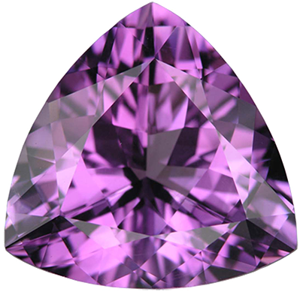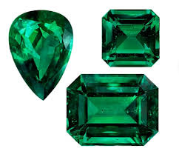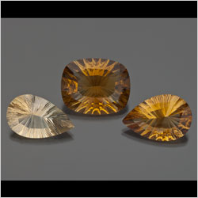

Industry Structure
Zambia is endowed with significant variety of high-quality gemstones throughout the country, notably emerald, tourmaline, aquamarine, amethyst, garnet, citrine, topaz, agate, rose and crystal quartz, malachite and beryl. The country boasts of being endowed with the second largest share of emeralds deposits in the world and produces about 20 % of the global emerald supply.

The products exported by the sector included semi-manufactured gold, precious or semi-precious stones, precious (excl. diamonds) or semi-precious stones and rubies, sapphires and emeralds, quartz, non-industrial diamonds and jewellery.

The main market for exports from this sector were South Africa, India, China, Hong Kong and Mauritius.

GEMSTONES COMPANY CONTACTS

COMPANY | ADDRESS | TEL/ EMAIL | Export Products
Jewel of Arica | No. 8 Nyerere Road, Longacres, Lusaka | Tel: +260961000553  Email: raj@jewelofafrica.com | Jewellery, cut and polished semi-precious stones
Kagem | Plot 6374 Dr Aggrey and Kariba Roads, P.O.Box 21657, KITWE | Tel: +260961021268 Email: kagem@zamnet.zm irvine.mwitwa@gemfields.co.uk | Emeralds
Kariba Minerals | P O Box 37080, Plot 11901, Kakota Road, Lusaka | Tel: +260-211-841059/ 0977813040  Email: jmwanza@karibaminerals.com | Amethyst
Gemcanton | Plot No. 8/E Pilala Area, Lufwanyama, Copperbelt | Tel: +260 212 211185/ +260960499218  Email: carolsampa@ymail.com  Erez.g@gemcanton.com | Emeralds
Eleora Gems | Lusaka, Zambia | Tel: +260 962153333/+260 978835073  Email: eleoragems@gmail.com mukoshamulenga@gmail.com  Website: www.eleoragems.com | Jewellery, cut and polished semi-precious stones
South Stream/ Exotica | Lima Hall, Showgrounds, P.O. Box 33342, Lusaka | Tel: + 260 211 262661/ +260966 743132  Email: ritarun1@gmail.com | Semi-precious stones
Nyakaula Gemstone Limited | P.O. Box 36742, Lusaka | Tel: +260 966 768136/ +260955778136  Email: nyakaulagems@yahoo.com | Semi-precious stones
Gramiraj | P O Box 34393, Chinika Industrial Area, Lusaka | Tel: +260 211 236465/ +260- 977-776926  Email: nanga@africamail.com | Semi-precious stones

HANDICRAFTS SECTOR
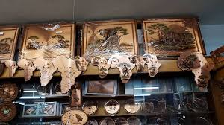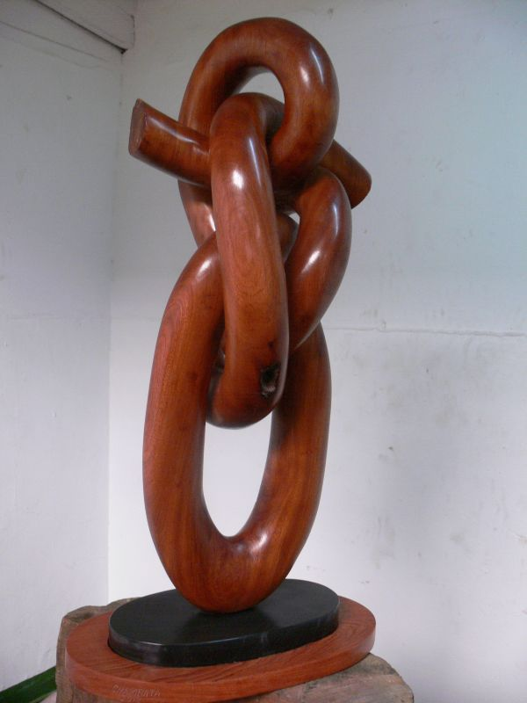
Industrial Structure

The handicrafts sector comprises specialized baskets, wood and stone carvings, clay products, metallic and gemstones products, ethnic jewellery, furniture items, African batiks (textile), copper art works and paint works on canvas and bark cloth. There is a growing trend amongst the producers to combine handicraft with fashion, this is signifying progression towards value addition and product differentiation.
As in the previous years, the sector continued to produce collections and collector's pieces of zoological interest, worked bone, tortoise-shell and horn, hand-made collages and similar decorative plaques, paintings, drawings and pastels executed entirely by hand and original sculptures and statuary. Top exporters Bangweulu Taxidermy Limited, Muchinga Adventure Limited, Bridge Shipping Zambia Limited, Van Staden Safaris Zambia Limited, Mopane Safaris Limited And Baobab Safaris Limited.

HANDICRAFTS & CURIOS COMPANY CONTACTS
COMPANY | ADDRESS | TEL/ EMAIL | Export Products
Kabwata Cultural Village | Burma Road, Lusaka | Tel: +26097 9291049, +260977698315  Email: | Handicrafts
Choma Museum | Choma | Tel: + 260 213 220394  Email: chomamuseum@gmail.com | Handicrafts
Miapen Crafts | Kabwe Road. P.O. Box 34843. Lusaka | Tel: + 260966767854  Email: miapencraft2000@yahoo.co.uk | Handicrafts
Kalisya | Burma Road, Lusaka | Tel:+260977698315  Email: | Handicrafts
Little Walk Enterprises | Plot 12092/H2, Woodlands Lusaka | Tel: + 260 954183766  Email: mwabambobola@gmail.com | Handicrafts
The Stitchin Post Interior Designers | Omelo Mumba Road, Rhodes Park, Lusaka | Tel: +260955293546  Email: thestitchinpostzm@gmail.com | Handicrafts
Cowrays | Chilenje, Lusaka | Tel: + 260 973101984  Email: mwambazibupe52@gmail.com | Handicrafts
Jeniza | 10310 Woodlands, Lusaka | Tel: 260 972446842  Email: jeanmutale82@gmail.com | Handicrafts
Kubu Crafts | Manda Hill Shopping Mall, Lusaka  International Airport, Livingstone  Mosi-O-Tunya Square, Livingstone (Head Office), | Tel: +260 977458576/ +260-213-320230/ +260 211 256644  EMAIL: kubu@kubucrafts.com lucy@kubucrafts.com  Website: https://kubucrafts.com/ | Handicrafts

LEATHER AND LEATHER PRODUCTS
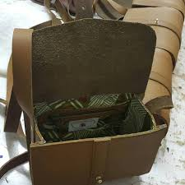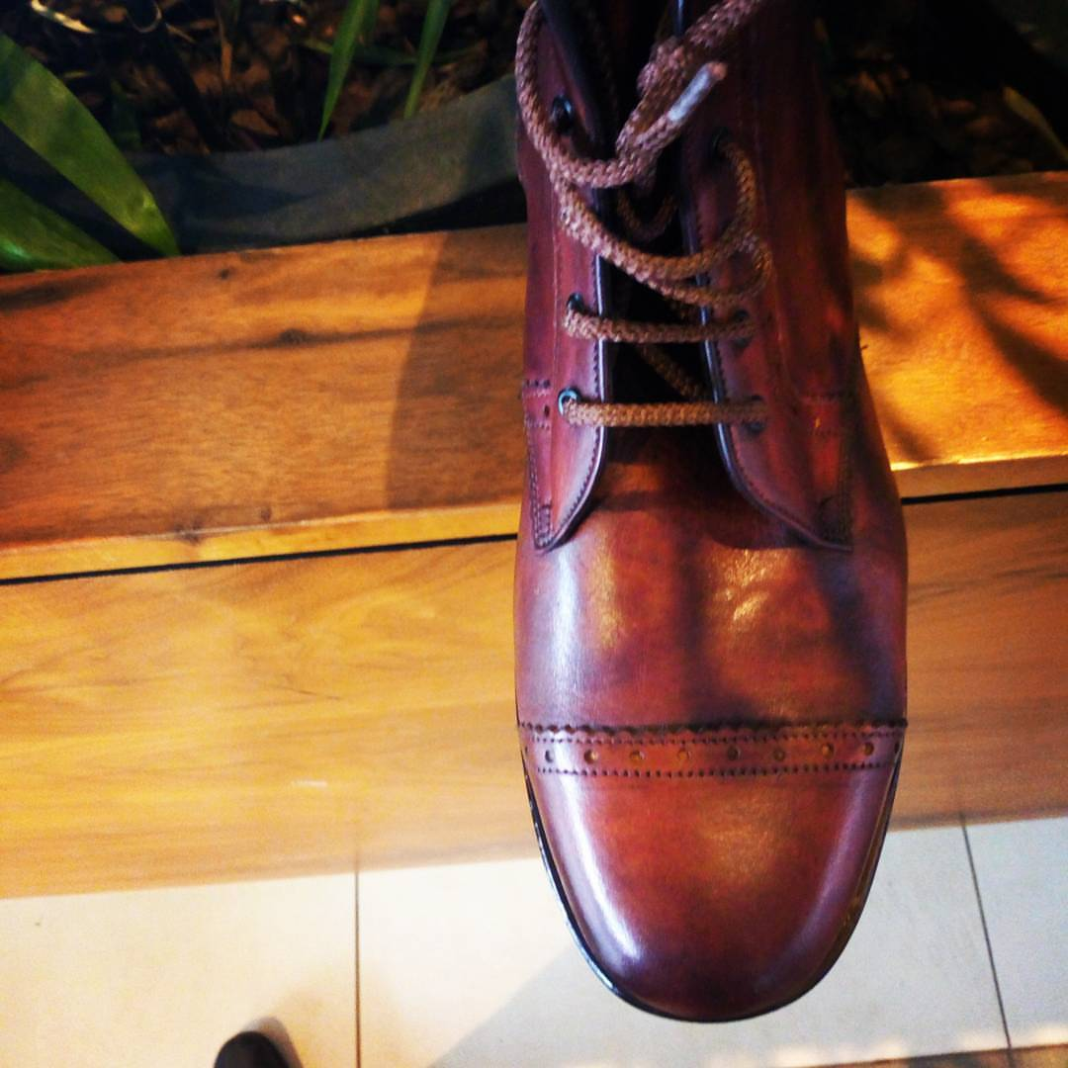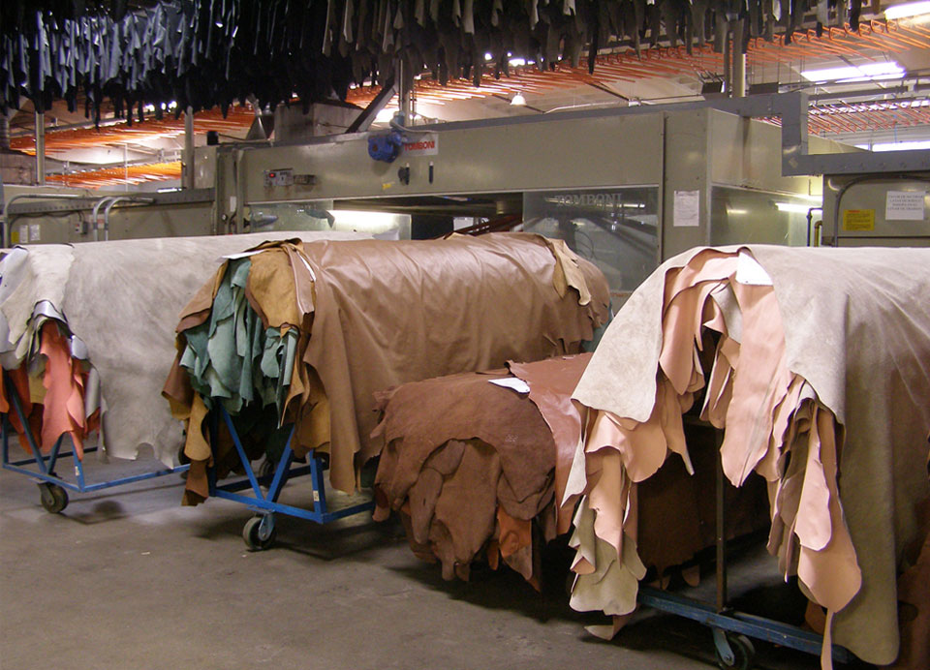
Industry Structure
The leather industry in Zambia is based on the livestock and wildlife as sources of raw materials, comprising mainly bovine hides, sheep and goat skins and crocodile skins as well as skins from wild animals. Key export products from the sector include crocodile skins, wet blue leather, crust, finished leather and leather goods. Specific products include printed leather (military), corrected grain (plain), corrected grain crust, crust lining, hunting calf, black splits, upholstery, vegetable kips, vegetable sole leather, moccasin suede, laminated football leather, industrial gloves/splits and insoles. Key leather goods include footwear, bags, gloves and protective clothing, soccer balls and household décor items.
The main export products included hides and skins of reptiles, wet blue, finished leather, protective gloves and foot wear. The main importing countries included Singapore, Congo DR, China, India and Italy.

LEATHER & LEATHER PRODUCTS company contacts
COMPANY | ADDRESS | TEL/ EMAIL | Export Products
Zamleather | Plot 10990 Mungwi Rd Industrial Area, Lusaka | Tel: +26021 124 1519 / +26021 124 1041 / +26021 124 0982  Email: | Leather shoes, wet blue, hides and other leather products
Copperbelt Shoes Limited | Plot 1806, Matipa Corner, Skyways, Ndola | Tel: + 260 212650301 / +260973006900  Email: copshulimited@gmail.com copshu@zamtel.com | Leather Shoes
Bata Shoe | Plot No. 6437, Mukwa Road, Industrial Area, Lusaak | Tel: + 260 211 24 5663  Email:  https://www.bata.co.zm/ | Shoes
Kalimba Farm | PO Box 38267, Ngwerere Lusaka, Zambia | Tel:+260 211 847190, +260 967 213272  Email: kalimba@zamsat.net | Crocodile Leather
Zongwe Farm | Sinazongwe | Tel: + 260 211 483114  Email: | Crocodile Leather
Fine Stitches | Benangombe Road Woodlands | Tel: +260966750135  Email: chisangakapumpa@gmail.com | Leather handbags

MINING
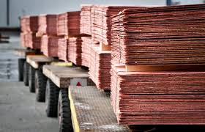

Industry Structure

The mining industry is the mainstay of Zambia’s economy. The main products of the sector include copper and cobalt. The sector also produces other products such as manganese, lead, silver and gold among others.
The major exporters in the sector include: Konkola Copper Mines, NFC Africa Mining Plc, Chibuluma Mines Plc, Mopani Copper mines, Lumwana Mining Limited, Chambeshi Copper Smelter Ltd, Albidon, Kansanshi Mining Plc, First Quantum Minerals (Bwana Mkubwa mine), Rubicon Mining Ltd and Sable Zinc Ltd. Other mining companies exporting minerals away from the traditional copper and cobalt include Kansanshi Mining Plc, Kampoko Resources Limited, Mopani Copper Mines Plc, Kagem Mining Limited, San He (Zambia) Limited, Datong International Trading Company, Konkola Copper Mines and Ferro Alloys Corporation Limited.
The main export products in the non-traditional mining sub sector were agglomerated iron ores and concentrates, aluminium ores and concentrates, anodic slimes, ash and residues containing leaded gasoline sludges and leaded anti-knock compounds sludge, bars, rods, sections, tubes and wire, bentonite, bullion semi-manufactured forms and chalk.
The major export markets for mining products were Australia, Austria, Botswana, Bulgaria, Canada, China, Congo Dr and Germany.

COMPANY | ADDRESS | TEL/ EMAIL | Export Products
Kalumbila (First Quantum Minerals) | Mwinilunga Road, Kalumbila, Solwezi District,  Plot 3805 Zambia Road, P.O. Box 230022, Ndola | Tel: +260963659783 / +260967686542  Email: mirriam.harmon@fqml.com  Website: www.first-quantum.com | Copper
Kansanshi Mining (First Quantum Minerals) | P.O. Box 110385, Solwezi | Tel: +260 212 658167/ +260 966 994 993  Email: godfrey.msiska@fqml.com | Copper
Mopani Copper Mines | P.O. Box 22000, Kitwe | Tel: + 260212247030/ +260962555746  Email: goodwell.mateyo@mopani.com.zm | Copper
Barrick Lumwana Mine | P.O. Box 110199, Mwinilinga Road, Lumwana East Solwezi | Tel: + 26082491502 / +260 977730148  Email: JKMusonda@barrick.com | Copper
Maamba Coilleeries | Head Office  PO Box 99  Maamba  Corporate Park,  Plot No. 20849 Alick Nkhata Road, P.O. Box 31197  Lusaka, | Tel : + 260 211 256010 | Coal
Munali Nickel Mine | Plot 10468  Kafue- Mazabuka Road  Mazabuka | Tel: +260 213 235190 / +260 213 235191  Email: info@mabiza.co.zm  gm@mabiza.co.zm  Website: http://www.mabiza.co.zm/ | Nickel
ZCCM – IH | Stand No. 16806, Alick Nkhata Road, P.O. Box 30048, Lusaka | Tel: + 260211388000 / +260 978366944  Email: chitib@zccm-ih.com.zm  lungujm@zccm-ih.com.zm  Website: www.zccm-ih.com.zm | Minerals

OTHER MANUFACTURES
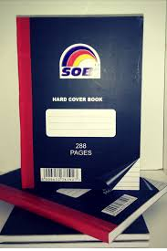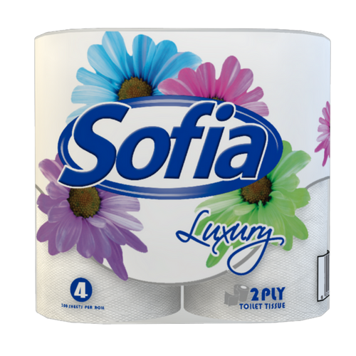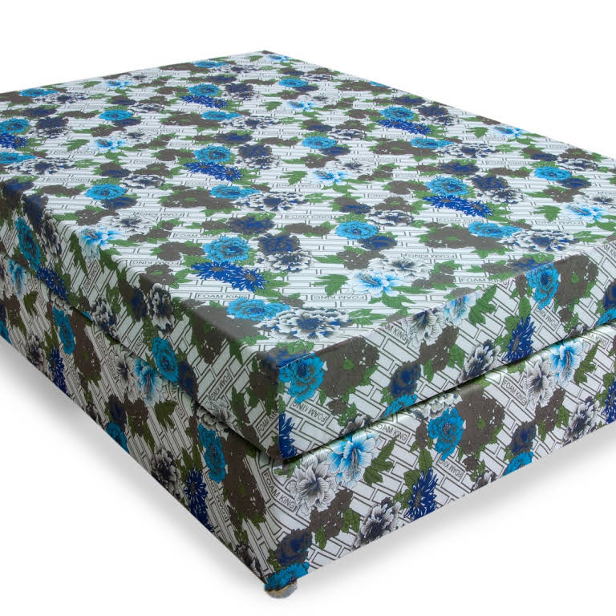

Industry Structure

The sector is composed of different companies that produce a wide variety of unrelated products. The products in this sector include: tissue paper, patapata, slippers, mattresses, exercise books and polythene products. Other notable products include plastic ware, printed matter and candles.

The main players in this sub sector are G4s Secure Solutions Zambia Limited, Stanbic Bank Zambia Limited, Standard Chartered Bank Zambia Plc, Barclays Bank Zambia Plc, Orica Zambia Limited, Kal Tire (Zambia) Limited, Zambia National Commercial Bank Limted, Tyreport Limited, Boxmore Packaging Zambia Limited and Gourock Plastics And Packaging Limited.

Major export products under the sub sector included cartons, boxes and cases, bank notes, safety fuses; detonating fuses; caps; igniters; electric detonators, preformed profiles, candles, tapers and plastics for packing of goods.

The main markets were the United Kingdom, Congo Dr, Switzerland, Zimbabwe, South Africa, Malawi and Hong Kong.

OTHER MANUFACTURES COMPANY CONTACTS

COMPANY | ADDRESS | TEL/ EMAIL | Export Products
Lamasat | Chipwenupwenu Road (Off Kafue Road) Makeni, Lusaka. Zambia. | Tel: +260 954 848 450  Email: sales@lamasat.co.zm | Diverse range of products
Lamise Investments | 397a Kafue Rd, Makeni, ‎P.O. Box 35126, Lusaka | Tel: + 26021 127 4427 / +26021 127 2076 / +26021 122 3459  Email: | Diverse range of products
Zambezi Incubator Hub | Plot 379/D1/D1 Chipwenupwenu Road, Makeni, Lusaka | Tel: + 260211273858/ +260963022222  Email:chunlei2100@msn.com incubatorcenter@outlook.com | Egg Incubators
Sobi Industries | Plot 5192 Luanshya Rd, P.O. Box 34841, Lusaka | Tel: +260 211 221247  Email: admin@sobi.co.zm | Various paper products
Gourock Zambia Limited | Arusha Street, P.O. Box 70467, Ndola | Tel:+260 212 615402/ 615658  Email: info@gourockzambia.com  Website: www.gourockzambia.com | Packaging, ropes, canvas, building materials, assorted food items and detergents.
Global Industries | Nakambala Road, Ndola | Tel: 260212650031/4/6/7 | Refined cooking oil and other products
U-Rest Foam | Makoli Ave. P.O.Box 70196 Ndola | Tel: +260 212 621616 / +260 212 621616  Email: sales@urestfoam.com  sales@urestfoam.com  Website: http://www.urest-foam.com/ | Mattresses
Kaylite Zambia | Blue Boar Road, Makeni, Lusaka | Tel: +260963412687  Email: kaylite.zam@gmail.com  Epssolutions.zam@gmail.com  Website: www.kaylitezambia.com | Expanded Polystyrene Products
Tins and Cans | P.O. Box 33392, Plot 36107/7, Off Mwembeshi Road, Lusaka | Tel: +260 979666086  Email: tins_cans@hotmail.com | Beverage closures
Nasla | NASLA GROUP P.O Box 31442 Lusaka | Tel: +260 21 184 5041  Email: nasla.zm@gmail.com | Various cosmetic products and detergents

PETROLEUM PRODUCTS
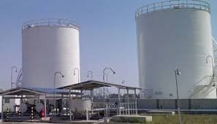

Industry Structure
Zambia’s petroleum products are wholly imported and there is a huge potential for renewable energy sources. Petroleum and coal are mainly used in commerce and industry. Zambia's total petroleum requirements are met through imports because the country does not have any proven reserves of crude oil. The products in this sector are petroleum gases, other oils and oil products, other light oils, pitch coke obtained from coal, petroleum jelly, cutting oil and lubricating grease.

The major players in the Petroleum oils sector are Spectra Oil Corporation Limited, Eastern Union Limited, Afrox Zambia Limited, Epiroc Zambia Limited, Zimwana Investments Ltd, Total Zambia Limited and Mount Meru Petroleum Zambia Limited.

The major export markets for Petroleum oil products from Zambia were Congo Dr, Zimbabwe, Kenya, Malawi, Congo, South Africa and Rwanda.

The main export products in this sector were Petroleum gases, Other Oils and Oil products, other light oils, Pitch Coke obtained from Coal, Petroleum Jelly, Cutting oil and Lubricating grease. Other oils.

PETROLEUM PRODUCTS COMPANY CONTACTS

COMPANY | ADDRESS | TEL/ EMAIL | Export Products
Afrox | Plot 4872 Sheki-Sheki Road, Industrial Area, Lusaka  (Head Office) Chisokone Avenue, Ndola, Zambia | Tel: +260-211-240954 / +260 212 611801/5 - 621608/9 - 621582 / +260 966 861416/17, +260 974 773431/32  Email: Dexter.Mumba@afrox.linde.com  Website: http://www.afrox-zambia.com/en/index.html | LPG
Oryx | Chishango Road, Lusaka |  | LPG
Spectra | Lumumba Road, Lusaka |  | Other oils
Delta Gases | P.O. Box 33011, Plot 14117, Chipwenupwenu Road, Off Kafue Road, Lusaka | Tel: +260976196321 Email: Bilal.iqbal@delta-gas.co | Oxygen Gas
Total | Buyantanshi Road, Industrial Area, Lusaka | Tel: + | Other oils
Puma | Buyantanshi Road, Industrial Area, Lusaka |  | Other oils
Indeni |  |  | Petroleum
Colas | Colas Zambia  Nakambala Road  Ndola | Tel: +260 212650733  Email: cobusbertram@colas-africa.com | Bitumen
Mount Meru | Mount Meru House, Zambezi Road, P.O. Box 33641, Luska | Tel: +260 211 255241  Email: svinerkar@mountmeru.co.zm | Other Oils
Chingases | P.O. Box 30188, Plot 12117/12118 Mumbwa Road, Lusaka | Tel: +260211 288104 | LPG

PRIMARY AGRICULTURE

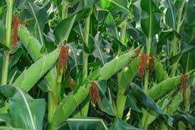
Industry Structure

Primary agricultural sector is one the critical contributing sectors to Zambia’s economic development, more so to Non- Traditional exports. The sector which is key both in terms of employment creation and production producing cash crops including Tobacco, Cotton and Coffee. Other products in the sector include maize, tea, sorghum, beans, millet, groundnuts, rice, seed and wheat.

The main players in 2016 included Tombwe Processing Company, Alliance One, Zdenakie Commodity Trading, Cargil 2000, Continental Ginnery, JTI Leaf Zambia, NWK Agri-Services Limited , Zambia Sugar Plc, Scz International Limited, Monsanto Zambia Limited and Pioneer Dupont Zambia Limited.

The sector mainly includes export crops such as tobacco, cotton, maize, raw cane sugar and soya beans. A major component of these exports includes seed for various products.

The major export markets were Switzerland, Kenya, China, Zimbabwe, South Africa, Malawi, Tanzania, Singapore and Germany.

PRIMARY AGRICULTURE COMPANY CONTACTS

COMPANY | ADDRESS | TEL/ EMAIL | Export Products
Tombwe Processing Limited | Plot 5055, Mungwi Road PO Box 35372 | Tel: +26 0211 846064  Email: tombwe@tombwe.co.zm  Website: http://tombwe.co.zm/ | Tobacco
JTI | Trinity Office Park, Plot 16806, Alick Nkhata Road, Mass Media, Lusaka | Tel: +260 965847488  Email: litiya.matakala@jti.com  Website: https://www.jti.com/africa/zambia | Tobacco
Grafax Cotton | Plot 6818, corner of Chimalamabwe & Kabile Road, Off Katima mulilo Rd, Olyimpia Extenstion | Tel: +260 963 808 402  Email: zambia@grafaxcotton.com  Website: http://zcga.org.zm/members/2.html | Cotton
Olam | First Floor,M-Life Building, Dar-es-Salaam Place, Cairo Road Lusaka  Kateshi Estate, Mbala RdPO Box 410208, Kasama  MailZambia@olamnet.com | Tel: +260 974 770 631  Email: zambia@olamnet.com  Website: https://www.olamgroup.com/locations/southern-africa/zambia.html | Coffee and cotton
Munali Coffee | Mubuyu Farms, 1633A Malambo Road, P.O. Box 33063, Lusaka | Phone: +260 211 244 241 Email : info@munalicoffee.com | Coffee
Zam Palm | Plot 4970, Manda Road, Industrial Area, Lusaka | Tel: +260 211 369 000 Fax: +260 211 369 050 Email: justok@zambeef.co.zm Website: www.zambeefplc.com | Palm oil

PROCESSED AND REFINED FOODS INDUSTRY
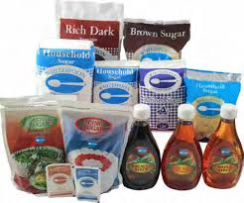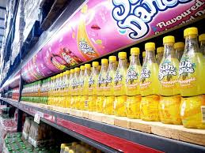
Industry Structure

The premier export earner of this sector is the sugar industry, with other important industries involved in grain milling (both maize and wheat). Other products include tomato pates, jam, peanut butter, dried fruits and vegetables, sun dried tomatoes, pineapple chunks, baked beans, onion and tomato mix. Value addition to locally produced products, the agro processing sector through processing is the key linkage to primary sectors like agriculture offering potential avenues for product development.

The main export products in the sub sector were oil-cake, non-alcoholic beverages, raw cane sugar, sweet biscuits, vegetable fats, sugar confectionery and bran.

The top exporters in this sector are Zambia Sugar Plc, Big Tree Beverages Limited, Dairy Gold Limited, Mount Meru Millers Zambia Limited, Global Industries Limited, Trade-Kings Limited, Varun Beverages (Zambia) Limited and Swiss Bake Limited.

The major markets for products in this sector were Congo Dr, Zimbabwe, South Africa, Rwanda, Malawi, Kenya, Tanzania and Namibia.

PROCESSED & REFINED FOODS company contacts

COMPANY | ADDRESS | TEL/ EMAIL | Export Products
Chankwakwa | P.O. Box 80721 Kabwe | Tel: +260 215 223848  Email: chankwakwa@gmail.com dorothy.eriksson@gmail.com  Website: http://www.chankwakwa.com | Dried fruit, jams and honey
Zambia Sugar | P.O. Box 30489, Malambo Road, Lusaka | Tel: +260 211 241 028  Email: Pkalamatila@zamsugar.zm Gchali@zamsugar.zm | Sugar
Comaco | Kachidza Road, Lusaka | stuarth@itswild.org dlewis@itswilg.org | Assorted food items
BigTree | Mumbwa Road, Lusaka | Tel: + 260 211 846307  Email: info@bigtreebev.com | Cereal (porridge)
Mpongwe Milling | Plot No. 5385 Mutentemuko Road, Heavy Industrial Area, Kitwe | Tel: +260 212 217301-4  Email: aashifgangat@mpongwemill.com.zm | Mealie Meal
Mount Meru Millers | P.O. Box 33641, Lusaka | Tel: +260 211 255241  Email: svinerkar@mountmeru.co.zm | Cooking oil
Quality Commodities | 397A Kafue Road, P.O. Box 32908, Lusaka | Tel: 260 211 272705  Email: devinder.chadha@qualitycommodities.com | Mealie Meal
Swiss Bake | Plot No. 7424 Chinka Area, Nampundwe Road, P.O. Box 30824, Lusaka | Tel: + 260 211 287267/68  Email: lukman@swissbake.co.zm | Confectionery
Zayan | Zambia House,  1118 Queens Road, The Main Mall  P.O.Box 362, Gaborone | Tel:+267-3951951  Email: zamhc@work.co.bw | Confectionery
Adcoms | No. 1 Great East Road Handsworth Park, P.O. Box 34906, Lusaka | Tel: + 260 211 955 886404  Email: adcomslimited@yahoo.com chaundwa10@gmail.com | Honey
Diamond Touch | 3850 Kambule Street, Mongu | Tel: +260 966 167272  Email: sydney.mwansa@diamondtouchzambia.com  Website: www.diamondtouchzambia.com | Rice and Cashewnuts
Yatu Tea | Kafue road, Stand No 26592C, Kafue Road, Makeni, Lusaka P.O.Box 260600 Kalulushi | Tel: +260 979 644621  Email: nashltd@gmail.com | Tea
Kawambwa Tea | Kawambwa Zambia | Tel: +26976 068837 Email msindano@gmail.com | Tea
Forest Fruits | Post net box 289 P/Bag E891, Lusaka | Tel: + 260 211 290406  Email: c.nawej@zambezigold.com  dball@zambezigold.com | Honey

WOOD AND WOOD PRODUCTS

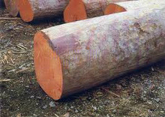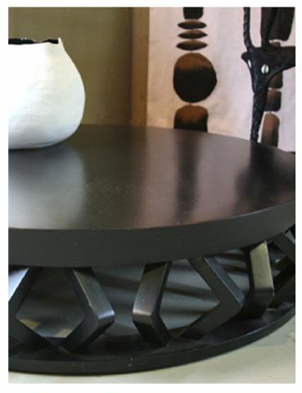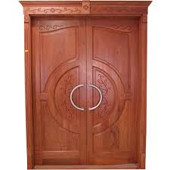
Industry Structure

The products manufactured and exported in this industry, include particleboards, railway sleepers, soft and hardwood-sawn timber, treated transmission poles, doors and frames, parquet tiles and edge glued panels. Other products are: garden tables, benches, timber frame houses and laminated kitchen boards.
Top exporters in the industry are ZAFICO, Forestry And Forest Industriy, Cnz Furniture Company Limited, Sikale Wood Manufacturers Limited, , Timber Junction Zambia Limited, Chep Pooling Solutions, Hensa Timber & Mining Contractors, Hermes Wood Industry Limited and Garden Timber Limited.

The main products exported included sawn timber, untreated coniferous wood, wood, pallets, parts of furniture, wooden furniture, wood marquetry, wooden furniture, flooring panels, wooden boards, cotton linters pulp, doors and wooden furniture.
The main export markets for the sector are China, South Africa, Congo Dr, Vietnam, Malawi, , Zimbabwe, Swaziland and Mozambique.

WOOD AND WOOD PRODUCTS company contacts
COMPANY | ADDRESS | TEL/ EMAIL | Export Products
Wood Processing |  |  | Wood products
ZAFICO | Private Bag 1, Mwekera, Kitwe | Tel: +260 212 239009  Email: rbinda4@yahoo.com | Timber
Copperbelt Forestry | 840 Nyerer Rd, Kitwe  Plot No 76/77, Forest Reserve Kitwe-Ndola Dual Carriage Way, Kitwe. | Tel: + 26021 221 7646 / +260-212-231413-15/ +260-950-169996/ +260955791666  Email: | Wood products
Kubu Crafts | Manda Hill Shopping Mall, Lusaka  International Airport, Livingstone  Mosi-O-Tunya | Tel: +260 977458576/ +260-213-320230/ +260 211 256644  EMAIL: kubu@kubucrafts.com lucy@kubucrafts.com  Website: https://kubucrafts.com/ | Wood products
Sikale Wood | No. 1938 Kasupe Road, P.O. Box 31078, Lusaka | Tel: + 260 973 313694/ 977 728888  Email: marketing@sikalewood.com  Website: www.sikalewood.com | Wood products
Chapu Enterprises | Zambian House, 48 Kwame Nkruma Ave,  RO. Box 4698, Harare | Tel: + 263-4-773777  Fax: + 263-4-773782  Email: zambiae@mweb.co.zw | Wood products

SERVICES

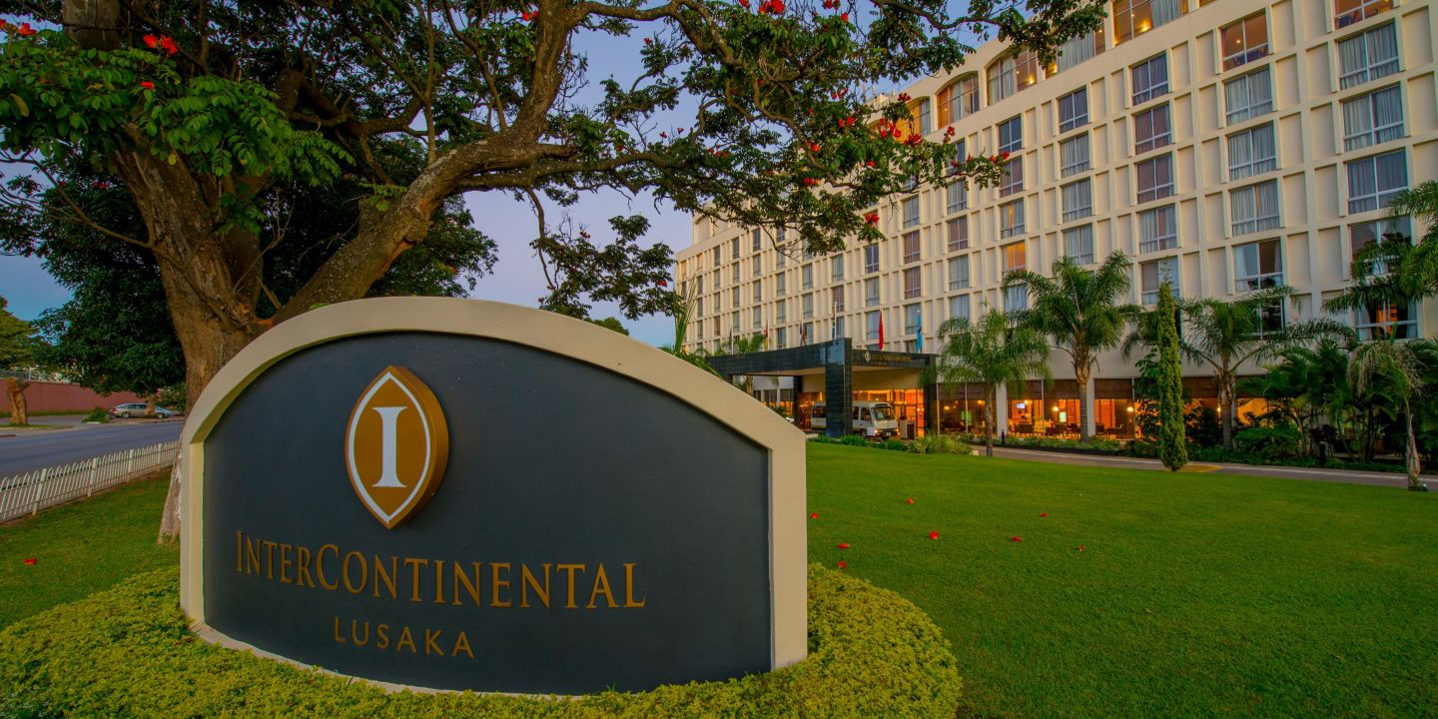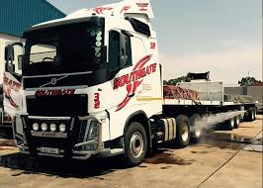

Industry Structure

The services sector is comprised of various exporting sectors which include products in finance, transport, communication, professional services, construction, tourism, education, health, business services, and distribution services among others. In Zambia, the services sector makes a significant contribution to GDP and export revenue.
Top exporters in the industry were travel, transport, manufacturing services on physical inputs owned by others, insurance and pension services, financial services, telecommunications, computer and information services, other business services and personal, cultural and recreational services.

SERVICES company contacts
COMPANY | ADDRESS | TEL/ EMAIL | Export Products
Southgate Transport | Plot 1635, Malambo Road and Plot 5127 Lumumba Road | Tel: +260 211 242 332 | Transport
J And J Transport | Plot 50 15 Linda Rd Bonaventure, Makeni, Lusaka | Tel: +260 21 127 8006  Email: info@jjzam.com  Website: http://www.jjafrica.com | Transport
Maersk Sealand | 1st floor of Garden Plaza building, Thabo Mbeki Road, Mass Media, Lusaka | Tel: +260 211 255591  Website: www.http://www.maersksealand.com | Shipping line
Katundu Link Zambia | 42, Chipwenupwenu Road, Lusaka | Tel: +260 967566666 Email: andy@chinakatundu.com Website: chinakatundu.com | Transport
Zamtel | Zamtel House, Chilubi Rd, Fairview, Lusaka | Tel: +260 (211) 333 152 Email: customercare@zamtel.co.zm | Telecommunications
Airtel | Stand 2375 C/O Great East Road and Addis Ababa Drive, Showgrounds, Lusaka | Tel: +260 977 770097  Email: customerservice@zm.airtel.com | Telecommunications
MTN | Mount Meru House, Zambezi Road, Roma Park, P.O. Box 35464, Lusaka | Tel: +260 966 750 750  Email: mtn@mtnzambia.co.zm | Telecommunications
Intercontinental Hotel | Haile Selassie Avenue , P.O. Box 32201 , Lusaka ,10101, Zambia | Tel: +260-211-250000  Email: reservations@lusakaic.com | Hotel Services
Avani Royal Livingstone Victoria Falls Zambia Hotel by Anantara  AVANI Victoria Falls Resort  Livingstone | PO Box 60151, Mosi-Oa-Tunya Road, Livingstone Zambia | Tel: +260 213 321122 | +260 978777044/7 Email: jsikabbubba@minorhotels.com Website: royal-livingstone.anantara.com avanihotels.com/victoria-falls | Hotel Services
Taj Pamodzi Hotel | Church Road, Lusaka, | Tel: +260 211 254 455 +260 971023081  Email: ajit.jha@tajhotels.com Website: www.tajhotels.com | Hotel Services
Chaminuka Lodge | Lusaka | Tel : 260 211 840883/4 +260 978 817211/965790800/1  Email: reservations@chaminuka.com  Website : www.chaminuka.com | Hotel Services, Cheese

PRODUCER ASSOCIATIONS

Most Zambian business associations act as a voice of the private sector, representing the interest of companies operating in their respective sectors. These associations work hand in hand with the these companies in the establishment, maintenance and consolidating close co-operation with relevant Government Ministries, departments as well as industry related national and regional organizations.

ASSOCIATION | ADDRESS | TEL/ EMAIL
Timber Producers Association of Zambia | P.O. Box 3324, Lusaka | Tel: +260 977655095 / +260966655095  Email: charlesmasange@gmail.com
Organic Producers Association of Zambia | Plot 14, Kabulonga. , P.O. Box 35317 , 10101 , Lusaka | Tel: +260 211 263070  Email: mchitalu@organic.org.zm  Website: www.oppaz.org.zm
Zambia Association of Manufacturers | Stand No. 2374 Mopani Drive, Showgrounds, Postnet Box 424 P/Bag E891, Mandahill, Lusaka | Tel: +260 211 253696  Email: info@zam.co.zm  Website: www.zam.co.zm
Zambia Association of Chambers of Commerce and Industry | Showgrounds,  P.O Box 30844, Lusaka | Phone: +260-211-252483  Telefax: +260-211-253020  Mobile:+260971581467  Email: secretariat@zacci.co.zm  Website: www.zambiachamber.org
Zambia Chamber of Small and Medium Business Associations | ZCSMBA Secretariat, Bluegum Walk, Showgrounds, P.O Box 32932, Lusaka | Tel: +260-21-125-3372  Website: https://www.zcsmba.org/
Zambia Chamber of Mines | Mpile Office Park, Ground Floor, 74 Independence Avenue, Stand No. 4953, P.O. Box 51393, Lusaka | Tel: +260211258383/3  Email: info@mines.org.zm  Website: www.mines.org.zm
Zambia National Farmers’ Union | Head Office, Farmers Village, Tiyende Pamodzi Road, Show Grounds, P.O. BOX 30395, Lusaka | TEL: +260 211 252649/ 255769/ 257958/254431/ 0977-722686
Lusaka Chamber of Commerce and Industry | Shreeji House, Addis Ababa Drive, P.O. Box 51074, Lusaka | Tel: +260978980170 / +260977276448  Email: lusakachamber@gmail.com  Website: www.lusakachamber.org
Zambia Livestock Cooperative Union Limited | Plot No. 1 Warthog Road, Kabulonga, P.O. Box 320242, Lusaka | Tel: +260976682147 / +260965327564 / +260972200022  Email: eliasnkhuwa2@gmail.com zlivestockcooperativeunion@gmail.com  Website: www.zalcul.org.zm
Zambia Agricultural Commodity Exchange | Plot No. 26592, Kafue Road, P.O. Box 34863, Lusaka | Tel: +260963719723 / +260977988897  Email: jmwale@zamace.co.zm  Website: www.zamace.co.zm
Zambia Federation of Associations of Women in Business | Ground Floor, Room 9, Kwacha House Annex, Cairo Road, Lusaka | Tel: +260211220812 / +260977751143  Email: zfawib@yahoo.co.uk  kawandamin@yahoo.com
Solwezi District Farmers’ Association | IFAD Building, Independence Avenue, P.O. Box 110210, Solwezi | Tel: +260975188782 / +260968616603  Email: dfa.solwezi@gmail.com daf.solwezi@gmail.com
Zambia Coffee Growers Association | Plot 7138, Mwembashi Road, P.O. Box 35388, Lusaka | Tel: +260955830120  Email: jtaguma@zcga.co.zm  Website: www.zcga.co.zm
Emerald and Semi Prsious Stone Mining Association of Zambia | Katilungu House, 3rd Floor, Room 2, P.O. Box 23071, Kitwe | Tel: +260979703399 / +260965948144 / +260955948144  Email: esmaz.zambia@yahoo.com chumweemeralds@hotmail.com
Handicraft Association of Zambia | Plot L/2085 Airport Road, Chelstone | Tel: +260 -977- 796 332  Email: jbkosa@gmail.com or cchilongo@yahoo.com
Federation of Small Scale Mining Associations of Zambia | Ministry of Works and Supply, Stand No. F9.1, Lusaka | Tel: +260977873559 / +260954100127  Email: fedessa@rocketmail.com

selected government ministries and Agencies

MINISTRY/ AGENCY | ADDRESS | TEL/ EMAIL
Ministry of Commerce, Trade and Industry | Government Complex, Kamwala, P.O. Box 31968, Lusaka | Tel: +260 211 226958  Email: contrade@zamnet.zm
Ministry of Foreign Affairs | Charter House, Independence Avenue, P.O. Box 50069, Lusaka | Tel: + 260 211 252666
Ministry of Agriculture | P.O. Box 50197 RW, Mulungushi ?House, 15100 Ridgeway, Lusaka | Tel: +260 211 250417
Ministry of Livestock and Fisheries | Mulungushi House,  P O Box 50060,  Lusaka | Tel: +260 977 413619  Email: info@mfl.gov.zm  Website: https://www.mfl.gov.zm/
Ministry of Mines | New Government Complex Building, Nasser Road, 12th & 14th Floor, P.O Box 31969, Kamwala, LUSAKA | Tel: +260 211 235320  Email: info@mmmd.gov.zm
Zambia Agricultural Research Institute | Mount Makulu, Private Bag 7, Chilanga | Tel: +260211278130/380  Email: mtmakulu@zamnet.zm  Email: zaridirector@zari.gov.zm
Zambia Bureau of Standards | Lechwe House, Freedom Way, PO Box 50259, Lusaka, Zambia | Tel: +260-1-231385/227075 E-mail: zabs@zamnet.zm Website: www.zabs.org.zm
Zambia Tourism Agency | 1st Floor Petroda House, Great East Road, Lusaka | Tel: +260 211 229087 – 90  Email: info@zambia.travel doris.kofi@zambia.travel  Website: https://www.zambia.travel/about-zta/
Bank of Zambia | Bank of Zambia, Cairo Road, P.O. Box 30008, Lusaka | Tel: +260-211-228888/228903-20 Email: pr@boz.zm
Competition and Consumer Protection Commission | 4th Floor Main Post Office, Cairo Road, P.O Box 34919, LUSAKA | Tel: 260 -211-222787, 232657 Email: zcomp@ccpc.org.zm Website: www.ccpc.org.zm
Department of Immigration | Kent Building, Haile Selassie Road, P.O. Box 50300, Lusaka, | Tel: +260 211 252831(Public Relations Office) +260 211 252622(Customer Service Center) Website: www.zambiaimmigration.gov.zm
Department of Veterinary & Livestock Development | Kabelenga Road, LUSAKA | Tel: +260-211-25 6679
Lusaka Stock Exchange | Farmers’ House, P.O. Box 34523, Lusaka | Tel: +260 211 228537/ 228391 E-mail: luse@zamnet.zm
Energy Regulation Board (ERB) | Off Alick Nkhata Road, Mass Media Area, Box 37631, Lusaka | Tel: +260-211-236002 Email: erb@erb.org.zm
Patents and Companies Registration Agency | Haile Selasie Avenue, LongAcres, P.O. Box 32020, Lusaka | Tel: +260 211255127/255127 Email: pacra@zamnet.zm Website: www.pacra.org.zm
Zambia Weights & Measures Agency | Plot 2387, Longolongo Rd, P. O Box 30989, LUSAKA | Tel: +260-211-22 2294, 021 123 6062 Email: zwema@zamnet.zm
Zambia Environmental Management Agency (ZEMA) | Corner of Church and Suez Roads, P.O. Box 35131, Lusaka | Tel: +260 211 254130/1 Website: www.zema.org.zm
Zambia Revenue Authority | Revenue House, Kalambo Road, P.O. Box 35710, Lusaka | Tel: +260 211 380000, +260 381111  Email: advice@zra.org.zm  Website: https://www.zra.org.zm/

ZAMBIAN MISSIONS ABROAD
COUNTRY | ADDRESS | TEL/ EMAIL
Australia | 40 Macquarie Street, Maddocks Building, BartonACT 2600, Canberra | Tel: +61470039936  Email: zamcanhc@gmail.com
Angola | 31-33 Rua Alanmenda do Principe real, Miramar,  P.O.Box 1496, Luanda | Tel: + 244-222-447491  Email: zambianembassyluanda@yahoo.com
Belgium | 469 Avenue Moliere,  1050 Brussels | Tel: + 32-2-3435649  Email: gov@zebru.org
Botswana | Zambia House,  1118 Queens Road, The Main Mall  P.O.Box 362, Gaborone | Tel:+267-3951951  Email: zamhc@work.co.bw
Brazil | Shis QL 10 Conjunto 10 Casa 17 Lago Sul Brasilia – DF, CEP: 71630-105 | Tel: +55 61 3248-3277  Email: zambiansbrasil@embaixadazambia.org.br
Canada | 151 Slater Street,  Suite 205, Ottawa,  Ontario, KIB 5H3 | Tel: + 1-613-2324400  Email: Ottawa@bellnet.ca
China | 5 Dong si jie, San Li Tun Beijing, 100600 | Tel: +8610-65 321 554/26  Email: diplomat@zambiaembassychina.cn
DR Congo | 54-58 Avenue de L’Ecole, Gombe B.P 1144, Kinshasa  Corner Ruwe/ Lufira, Zone Lubumbashi B.P 596 | Tel: + 243-815565994  Email: zamkins@vodanet.cd  Tel: +243-815581394  Email: zamconsgen@ic-lubum.cd
Egypt | 20 Damascus Street, off Syria Street, Mohandeseen, Cairo | Tel: + 20-2-376102881  Email: zamcairo@gmail.com zambiacairo@gmail.com
Ethiopia | Old airport Area, Higher 23,  Kebele 12, P.O. Box 1909, Addis Ababa | Tel: +251-11-3711302  Email: commsadd@gmail.com
France | 18, Avenue de Tourville 75007, Paris | Tel: + 33-1-56881272  Email: zambiansparis@wanadoo.fr
Germany | Axel-Springer-Strasse.54A 10117, Berlin | Tel: +49-30-2062940  Email: secretary@zambiaembassy.de
Ghana | 12 Nme Lane, Airport Residential Area, Cantoments, PMB CT 288, Accra | Tel: 233 021782298  Email: info@zambiahighghana.org
India | D 5/4, Vasant Vihar, New Delhi | Tel: + 91-1141808374  Email: zambiand@sify.com zambiand@gmail.com
Israel | 3 Nrim Street, 3rd Floor, Canada House, Tel Aviv | Tel: +972543437714  Email: zamtel2015@gmail.com  brightonlitula@gmail.com
Italy | Via Ennio Quirino Visconti, 8 Rome 00193 | Tel: + 39-0636002590  Email: info@zambiaembassy.it
Japan | 10-2, Ebara 1- Shinagawa-Ku, C.RO Box 1 738, Tokyo 142-0063 | Tel: +81-334910121  Email: emb@zambia.or.jp
Kenya | Nyerere Road, P.O. Box 48741, 001100 Nairobi | Tel: + 254-202724799, +254 737567962  Email: zambiacom@swiftkenya.com
Libya | 10 Maldina El Syahiya Gyrgaeeh, P.O. Box 01860, Dhatelemad, Tripoli | Tel: + 218-21-4834709
Malawi | Plot No.2 Area 40, P.O. Box 30138, Lilongwe | Tel: + 265-1-772590  Email: zambiahighcom@globemw.net
Malaysia | Suite C, 5th Floor, Menera MBF, Jalan Sultan Ismail 50250, Kuala Lumpur | Tel: +60321453512  Email: info@zhckl.com.my
Mozambique | Avenida Kenneth Kaunda 1286, P.O. Box 46655, Maputo | Tel: + 258-2-1-492452  Email: zhcmmap@tvcabo.co.mz
Namibia | 22 Sam Nujoma Drive,  Cnr. Mandune Ndemufayo Rd,  P.O. Box 22882, Windhoek | Tel: +264-61-237610 Email: zahico@iway.na
Nigeria | Plot 351 Mission Road,  Central District Area, Garki, RM.B 5055; Wuse, Abuja | Tel: + 234-9-4618605  Email: info@zambiahcng.org  zambiahigcommission@gmail.com
Russia | Prospect Mira 52 A, Moscow | Tel: + 74 956885001  Email: zambiansmoscow@gmail.com
Saudi Arabia | 10 Abdulrahman Al Maliq Road, Al Mursalaat District, Riyadh | Tel: +966114542295  Email: zembassy@yahoo.com
South Africa | 570 Ziervogel Street Off Hamilton Street, Arcadia P.O. Box 12234, Pretoria | Tel: + 27-12-3261847  Email: hc@zambiapretoria.net
South Korea | 2 Hoenamu-Ro 44 Gil, (258-8 Itaewon-Dong), Yongsan-gu | Tel: +82-27931961  Email: zamembseoul@gmail.com
Sweden | Gardsvagen 18, 3rd Floor, P.O.Box 3056, 169 03 Stockholm, Solna | Tel: +46-8-6799040  Email: info@zambiaembassy.se
Switzerland | 17-19, Chemin du Champ-D'anier, 1209, Le Peti-Saconnex, Geneva | Tel: +41-22-7614400  Email: mission.zambia@ties.itu.int
Tanzania | 5&8 Ohio/Sokoine Drive, P.O. Box 2525, Dar es salaam | Tel: + 255-22-2118482  Email: info@zhcdar.or.tz
Turkey | ILK BaharMah, 610 Solak, No. 9 Cankaya, Ankara | Tel: +90-312-428-1040  Email: zambiaturkey@gmail.com
United Kingdom | Zambia House, 2, Palace Gate, London W8 5NG, London | Tel: +44-207-5896655  Email: zhcl@btconnect.com info@zambiahc.org.uk  Website: www.zhcl.org.uk
United Nations, Permanent Mission | 237 East 52nd Street, NewYork, NY 10022 | Tel: + 1-212-8885770  Email: zambia@un.int
United States of America | 2419 Massachusetts Avenue, N. W, Washington D. C 20008 | Tel: + 1-202-2659717  Email: embzambia@aol.com info@zambiaembassy.org
Zimbabwe | Zambian House, 48 Kwame Nkruma Ave,  RO. Box 4698, Harare | Tel: + 263-4-773777  Fax: + 263-4-773782  Email: zambiae@mweb.co.zw

FOREIGN MISSIONS ACCREDITED TO ZAMBIA
COUNTRY |  |  | ADDRESS | TEL/ EMAIL
Angola |  |  | No. 6660 Mumada Road, Qlympia P.O Box 31595, Lusaka | Tel: +260 – 211-292277 Email: embaixada.zambia@mirex.gov.ao
Belgium Consulate |  |  | 5001 Mumbwa Road  C/0 Zamanita Premier oils, P.O. Box 31412, Lusaka | Tel: +260-211-286460 ext 221/233  Fax: +260-211-286461
Botswana |  |  | 5201 Pandit Nehru Road, Diplomatic Triangle P. O Box 31910, Lusaka | Tel: +260 – 211-250555 / 252895 Email:
Brazilian |  |  | 4, Manenekela Road – Woodlands,  P.O.Box 33737, Lusaka | Tel: +260-211-252171 Email: brasemb.lusaca@itamaraty.gov.br
Britain (United Kingdom) |  |  | 5210 Independence Avenue P.O Box 50050, Lusaka | Tel: +260-211-251133  Email: BHC-Lusaka@fco.gov.uk
Bulgaria |  |  | 4045 Lukuku Road, Sunningdale PO. Box 31996, Lusaka | Tel: +260 - 211- 263295 / 253798 +260-211-263295
Burundi |  |  | 6 United Nations Avenue Lusaka | Tel:+260211258810  Email: ambabulska2012@yahoo.com
China |  |  | 7430, United Nations Avenue  PO, Box 31975, Lusaka | Tel: +260 - 211- 252410  Email: chinaemb_zm@mfa.gov.cn
Cuba |  |  | 5574 Magoye Road, Kalundu,  Lusaka | Tel: +260 - 211- 291308 Email: ambassador@iconnect.zm administacion@iconnect.zm
DR Congo |  |  | No. 1124, Parirenyatwa Rd, P.O Box 31287 Lusaka | Tel: +260 – 977873892 Email: ambardclusaka@gmail.com
Egypt |  |  | 5206 United Nations Avenue,  Longacres Lusaka | Tel: +260-211-250229  Email:
European Union |  |  | Plots 4899,  Los Angeles Boulevard, Longacres  PO, Box 34871, Lusaka | Tel: +260 - 211- 250711 / 251140 / 255585  Email: DELEGATION-ZAMBIA@eeas.europa.eu Website: http://eeas.europa.eu/delegations/Zambia
Finland |  |  | Haile Selassie Avenue,  Opposite Ndeke Hse, Longacres,  P.O. Box 50819, Lusaka | Tel: +260 - 211- 251988 / 257422  Email: sanomat.lus@formin.fi
France |  |  | 74 Independence Avenue P.O Box 30062,  Lusaka | Tel: +260-211-251322  Email: cad.lumsaka-amba@diplomatie.gouv.fr
Germany |  |  | No. 5209 United Nations Avenue, P.O Box 5012, Ridgeway, Lusaka | Tel: +260-211-25 06 44  Email: info@lusaka.diplo.de Website: www.lusaka.diplo.de
Ghana |  |  | 28 Bwinjimfumu Road, Rhodes Park, P.O Box RW 50515, Lusaka | Tel: +260-211-238128  Email: info@ghczambia.com ghcomlsk@gmail.com Website: www.ghczambia.com
Holy See |  |  | 283 Los Angeles Boulevard, Long Acres, P.O Box 31445, Lusaka | Tel: +260211250786 Email: nuntius@coppernet.zm
India |  |  | 1, Pandit Nehru Road, Longacres,  P.O Box 32111, Lusaka | Tel: +260 - 211- 253159/ 60  Email: hc.lusaka@mea.gov.in hoc.lusaka@mea.gov.in
Ireland |  |  | No. 6663 Katima Mulilo Road,  Olympia Extension  PO. Box 34923, Lusaka | Tel: +260 - 211- 290650  Email: lusakaembassy@dfat.ie Website: www.embassyofireland.co.zm
Italy |  |  | No. 5211 Diplomatic Triangle, Embassy Park  P.O Box 50497, Lusaka | Tel: +260-211-250 781  Email: ambasciata.lusaka@ester.it
Japan |  |  | 5218 Haile Salassie Avenue, Longacres  PO. Box 34190, Lusaka | Tel: +260-211- 251555  Email: jez@lu.mofa.go.jp
Kenya |  |  | 5207 United Nations Avenue  P.O. Box 50298, Lusaka | Tel: +260 - 211- 250722 Email: highcommissioner@kenyamission.org.zm
Korea (North) |  |  | No MC 97 PHI Bennie Mwiinga, P.O. Box 31796, Lusaka | Tel: +260 250 722 Email: zamkrc@yahoo.com
Libya |  |  | No. 4900 Los Angeles Boulevard, Longacres,  P.O. Box 35319, Lusaka | Tel: +260-211- 253055 255388  Email: Lybia_zambia@yahoo.com
Malawi |  |  | 31 Bishop's Road  P.O.Box 50425  Kabulonga, Lusaka | Tel: +260-211- 265768/9  Email: mhcomm@iwayafrica.com Website: www.malawimissionlusaka.info
Mozambique |  |  | No. 9592 Kacha Read, Northmead,  P.O. Box 34877, Lusaka | Tel: +260-211- 220333,239135  Email: embamoc.zambia@gmail.com
Namibia |  |  | 508 Mutende Road, Woodlands  P.0. Box 30577, Lusaka | Tel: +260- 211-260407  Email: namibia@coppernet.zm
Nigeria |  |  | No. 50203 Haile Selassie Avenue,  Longacres Lusaka | Tel: +260 - 211- 254520  Email: megnigerialusaka@yahoo.com
Norway |  |  | Plot 245/61 Corner Birdage Walk/Haile Seisssie Avenue, P.O. Box 34570, Lusaka | Tel: +260-211-25 21 88  Email: mailto: emb.lusaka@mfa.no
Russia |  |  | Plot no, 6407 Diplomatic Triangle,  P.O. Box 32355, Lusaka | Tel: +260 - 211- 252120/252183  Email: rusembzambia@mid.ru embruszambia@gmail.com
Saudi Arabia |  |  | 27 BC Leopard Hill Road  P.O. Box 34411, Lusaka | Tel: +260-211- 266861/2  E-mail: zmemb@mofa.gov.sa
Serbia |  |  | No. 5216 Independence Avenue, P.O Box 33379, Lusaka | Tel: +260-211- 250235  Email: serbianemba@zamnet.zm
Sudan |  |  | 31 Ngumbo Road  Long Acres, Private Bag 179x Ridgeway,  Lusaka | Tel: +260 -211- 252116  Email: sudemblsk@iconnect.zm
Sweden |  |  | Haile Selasie Avenue,  Opposite Ndeke House, P.O Box 50264,  Lusaka | Tel: +260-211-251711  Email: ambassaden.lusaka@foreign.ministry.se
Somalia |  |  | G3/377A Kabulonga Road, Kabulonga  P.0. Box 34051 Lusaka | Tel: +260-211- 263944  Email: dawara7@hotmail.com
South African |  |  | D26 Cheetah Road, Kabulonga  Private Bag W 369,  Lusaka | Tel: +260 - 211- 260999  E-mail: sahcadmin@dirco.gov.za
Tanzania |  |  | Ujamaa House, No. 5200  United Nations Avenue  Box 31219, Lusaka | Tel: +260 - 211- 253323  Email: tanzanhighcom@zambia.co.zm
United States of America |  |  | Subdivision 695/ Stand 100, Ibex Hill Road, Ibex Hill,  P.O. Box 31617,  Lusaka | Tel: +260-211- 357000  Email: ConsularLusaka@state.gov  Website: http://zambia.usembassy.gov
Zimbabwe |  |  | No. 11058 Haile Selassie Avenue,  Longacres  P.O. Box 33491, Lusaka | Tel: +260 - 211- 254022/12  Email: info@zimembassy.org.zm



